**VISVESVARAYA TECHNOLOGICAL UNIVERSITY**

**“JnanaSangama”, Belgaum -590014, Karnataka.**



**LAB REPORT**

**on**

**Object Oriented Java Programming**

**(23CS3PCOOJ)**

***Submitted by***

**Hitha Harish (1BM23CS115)**

***in partial fulfillment for the award of the degree of***

**BACHELOR OF ENGINEERING**

***in***

**COMPUTER SCIENCE AND ENGINEERING**



**B.M.S. COLLEGE OF ENGINEERING**

**(Autonomous Institution under VTU)**

**BENGALURU-560019**

**Sep-202**

**B.M.S. College of Engineering,**

**Bull Temple Road, Bangalore 560019**

(Affiliated To Visvesvaraya Technological University, Belgaum)

**Department of Computer Science and Engineering**



**CERTIFICATE**

This is to certify that the Lab work entitled “Object Oriented Java(23CS3PCOOJ)” carried out by **Hitha Harish (1BM23CS115),** who is bonafide student of **B.M.S. College of Engineering.** It is in partial fulfillment for the award of **Bachelor of Engineering in Computer Science and Engineering** of the Visvesvaraya Technological University, Belgaum. The Lab report has been approved as it satisfies the academic requirements in respect of an Object Oriented Java (23CS3PCOOJ ) work prescribed for the said degree.

|  |  |
| --- | --- |
| Ambuja K  Assistant Professor  Department of CSE, BMSCE | Dr. Kavitha Sooda  Professor & HOD  Department of CSE, BMSCE |

**Index**

|  |  |  |  |
| --- | --- | --- | --- |
| **Sl.**  **No.** | **Date** | **Experiment Title** | **Page No.** |
| 1 | 24/9/24 | Programs in C | 4 |
| 2 | 1/10/24 | Addition, Product of 2 numbers. Quadratic Expressions | 14 |
| 3 | 8/10/24 | Class Student to take details of the student and calculate SGPA | 18 |
| 4 | 15/10/24 | Class Book to take the details of a book using Constructors, and set methods. Display the details using get methods and toString() | 25 |
| 5 | 22/10/24 | Abstract class Animal  Abstract class Shape | 31 |
| 6 | 29/10/24 | Class Account – Savings and Current | 39 |
| 7 | 10/11/24 | Package CIE and SEE | 47 |
| 8 | 19/11/24 | Interface Programs | 55 |
| 9 | 26/11/24 | Exceptions | 60 |
| 10 | 3/12/24 | Threads | 64 |

Github Link: <https://github.com/HithaHarish-csbmsce/OOJ>

**Lab 1**

**Program1:**

**Code:**

#include <stdio.h>

int main() {

int num;

printf("Enter an integer: ");

scanf("%d", &num);

if (num % 2 == 0) {

printf("%d is even.\n", num); // If remainder is 0, it's even

} else {

printf("%d is odd.\n", num); // Otherwise, it's odd

}

return 0;

}

**Output:**

Enter an integer: 7

7 is odd.

Enter an integer: 12

12 is even.

**Program2:**

#include <stdio.h>

int main() {

int num;

printf("Enter an integer: ");

scanf("%d", &num);

if (num % 2 != 0) {

int square = num * num; // Calculate the square of the odd number

printf("The square of %d is %d.\n", num, square);

if (square % 2 == 0) {

printf("The square of %d is even.\n", num);

} else {

printf("The square of %d is odd.\n", num);

}

} else {

printf("%d is not an odd number.\n", num);

}

return 0;

}

**Output:**

Enter an integer: 5

The square of 5 is 25.

The square of 5 is odd.

Enter an integer: 3

The square of 3 is 9.

The square of 3 is odd.

Enter an integer: 4

4 is not an odd number.

**Program3:**

#include <stdio.h>

int main() {

int numerator, denominator;

printf("Enter numerator: ");

scanf("%d", &numerator);

printf("Enter denominator: ");

scanf("%d", &denominator);

if (denominator == 0) {

printf("Error: Division by zero is not allowed!\n");

} else {

int result = numerator / denominator;

printf("Result: %d / %d = %d\n", numerator, denominator, result);

}

return 0;

}

**Output:**

Enter numerator: 10

Enter denominator: 2

Result: 10 / 2 = 5

Enter numerator: 10

Enter denominator: 0

Error: Division by zero is not allowed!

**Program4:**

#include <stdio.h>

int main() {

int num;

printf("Enter a number: ");

scanf("%d", &num);

if (num % 2 == 0) {

printf("%d is even.\n", num);

} else {

printf("%d is odd.\n", num);

}

printf("Numbers from 1 to %d in ascending order:\n", num);

int i = 1;

while (i <= num) {

printf("%d ", i);

i++;

}

printf("\n");

printf("Numbers from %d down to 0 in descending order:\n", num);

int j = num;

do {

printf("%d ", j);

j--;

} while (j >= 0);

printf("\n");

return 0;

}

**Output:**

Enter a number: 5

5 is odd.

Numbers from 1 to 5 in ascending order:

1 2 3 4 5

Numbers from 5 down to 0 in descending order:

5 4 3 2 1 0

Enter a number: 6

6 is even.

Numbers from 1 to 6 in ascending order:

1 2 3 4 5 6

Numbers from 6 down to 0 in descending order:

6 5 4 3 2 1 0

**Program5:**

#include <stdio.h>

int main() {

int num1, num2;

char operator;

printf("Enter first number: ");

scanf("%d", &num1);

printf("Enter an operator (+, -, *, /, %%): ");

scanf(" %c", &operator);

printf("Enter second number: ");

scanf("%d", &num2);

switch (operator) {

case '+':

printf("%d + %d = %d\n", num1, num2, num1 + num2);

break;

case '-':

printf("%d - %d = %d\n", num1, num2, num1 - num2);

break;

case '*':

printf("%d * %d = %d\n", num1, num2, num1 * num2);

break;

case '/':

if (num2 == 0) {

printf("Error: Division by zero is not allowed!\n");

} else {

printf("%d / %d = %.2f\n", num1, num2, (float)num1 / num2);

}

break;

case '%':

// Check for modulus by zero

if (num2 == 0) {

printf("Error: Modulus by zero is not allowed!\n");

} else {

printf("%d %% %d = %d\n", num1, num2, num1 % num2);

}

break;

default:

printf("Error: Invalid operator!\n");

break;

}

return 0;

}

**Output:**

Enter first number: 12

Enter an operator (+, -, *, /, %): +

Enter second number: 5

12 + 5 = 17

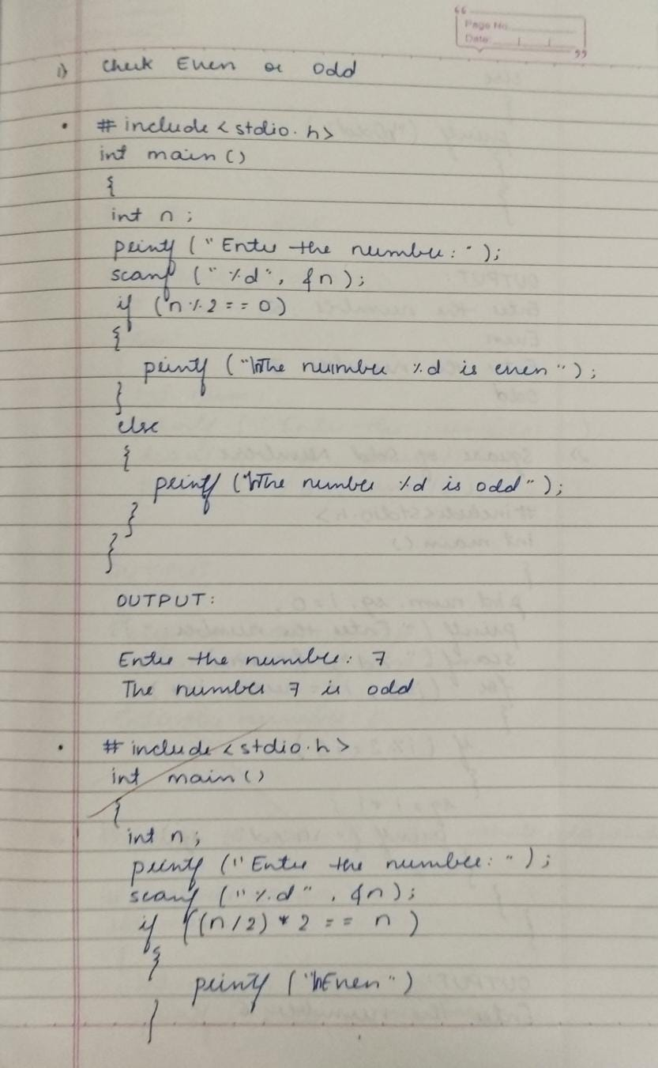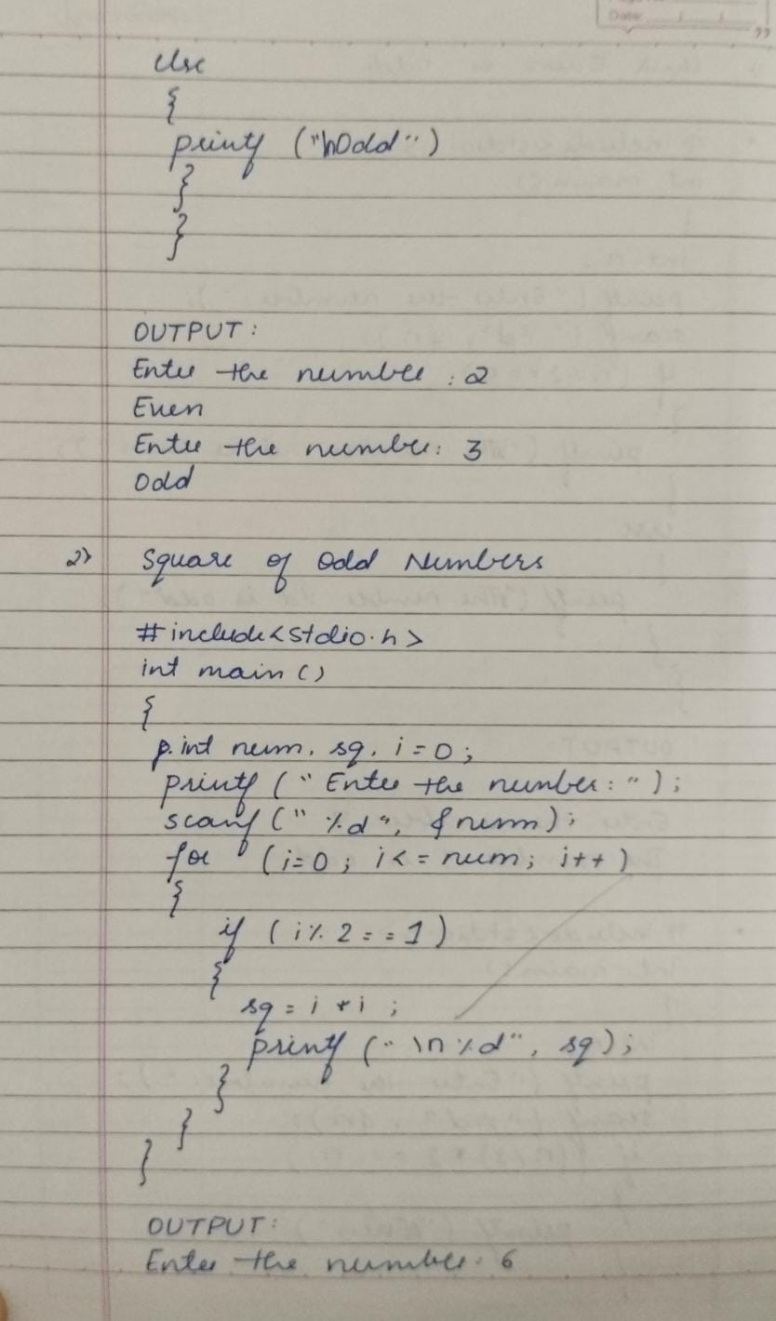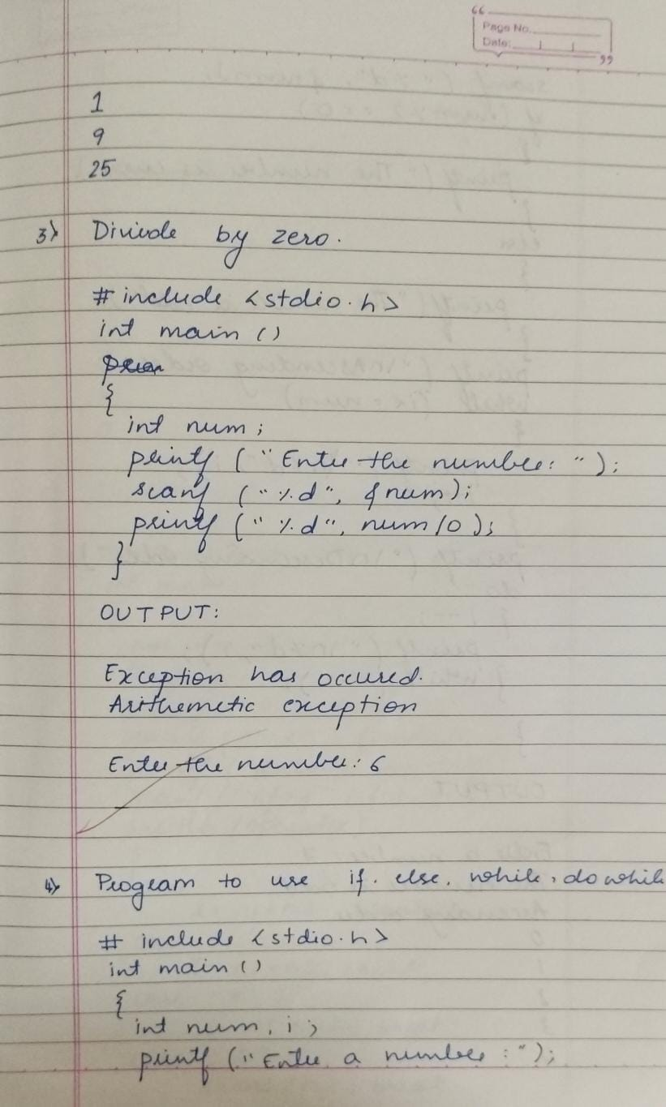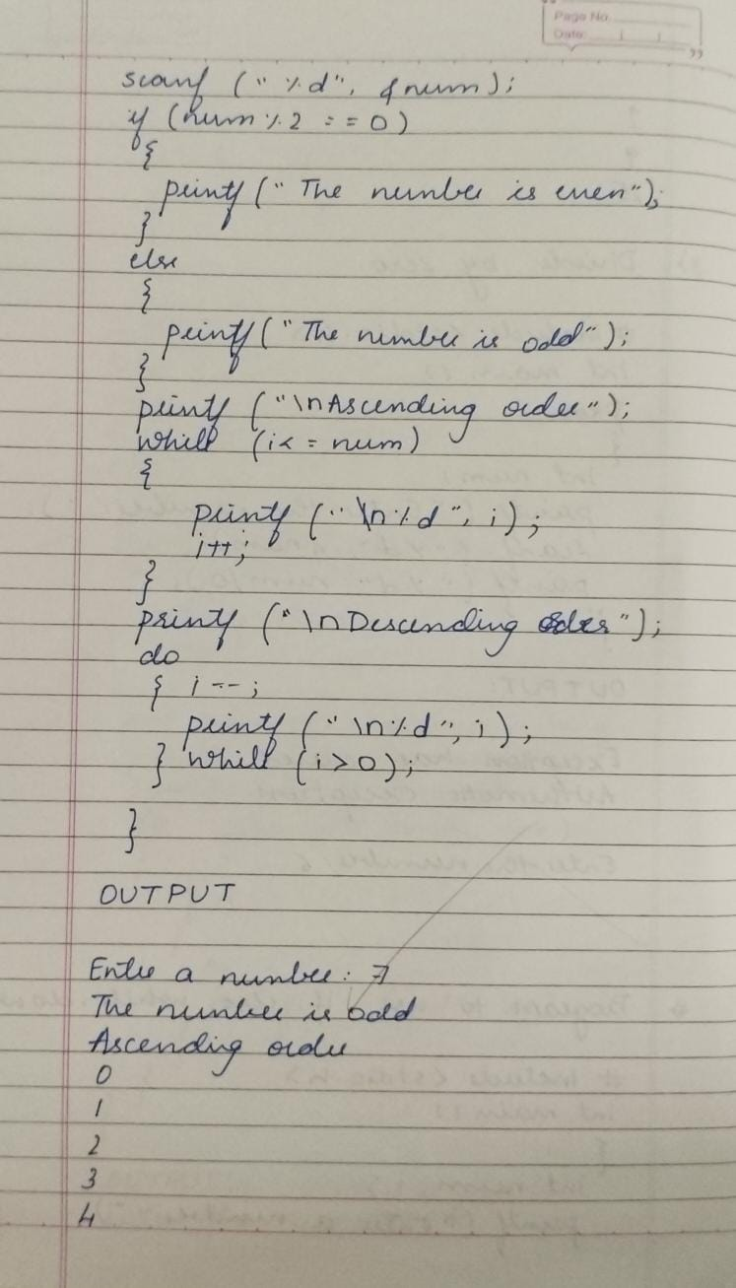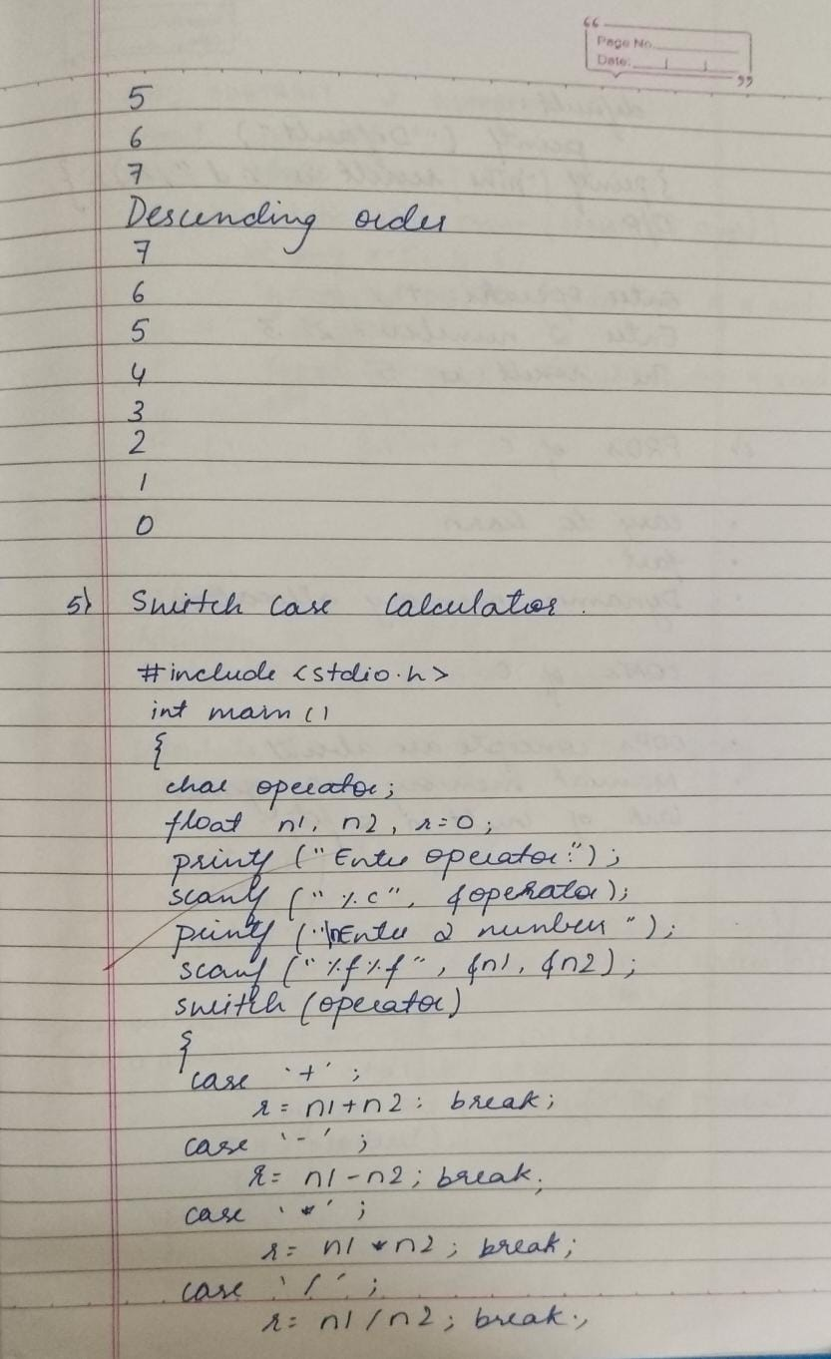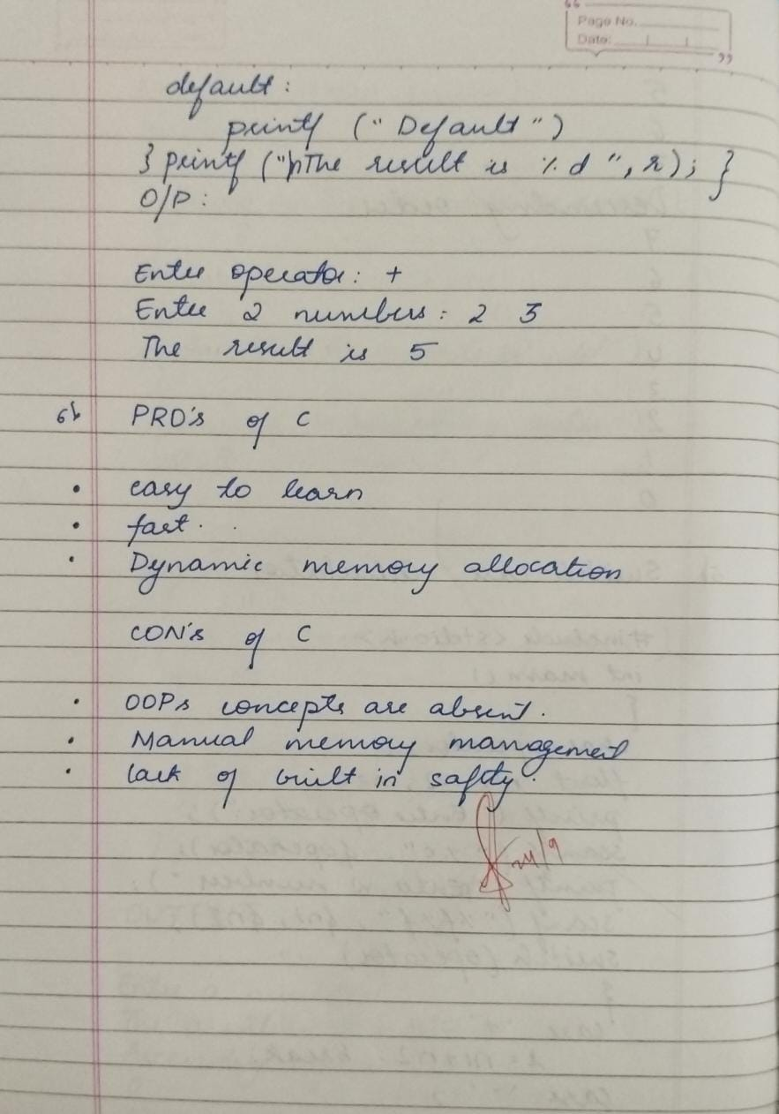

**Lab2**

**Program1:**

public class SimpleCalculator {

public static void main(String[] args) {

int num1 = 10;

int num2 = 5;

int sum = num1 + num2;

int difference = num1 - num2;

System.out.println("Sum of " + num1 + " and " + num2 + " is: " + sum);

System.out.println("Difference between " + num1 + " and " + num2 + " is: " + difference);

}

}

**Output:**

Sum of 10 and 5 is: 15

Difference between 10 and 5 is: 5

**Program2:**

import java.util.Scanner;

public class Calculator {

public static void main(String[] args) {

Scanner scanner = new Scanner(System.in);

System.out.print("Enter the first number: ");

double num1 = scanner.nextDouble();

System.out.print("Enter the second number: ");

double num2 = scanner.nextDouble();

double product = num1 * num2;

double quotient = 0.0;

if (num2 != 0) {

quotient = num1 / num2;

System.out.println("Division result: " + quotient);

} else {

System.out.println("Error: Division by zero is not allowed.");

}

System.out.println("Product (multiplication) of " + num1 + " and " + num2 + " is: " + product);

}

}

**Output:**

Enter the first number: 10

Enter the second number: 5

Product (multiplication) of 10.0 and 5.0 is: 50.0

Division result: 2.0

**Program3:**

import java.util.Scanner;

import java.lang.Math;

public class QuadraticEquation {

public static void main(String[] args) {

Scanner scanner = new Scanner(System.in);

System.out.print("Enter coefficient a: ");

double a = scanner.nextDouble();

System.out.print("Enter coefficient b: ");

double b = scanner.nextDouble();

System.out.print("Enter coefficient c: ");

double c = scanner.nextDouble();

double discriminant = b * b - 4 * a * c;

if (discriminant > 0) {

double root1 = (-b + Math.sqrt(discriminant)) / (2 * a);

double root2 = (-b - Math.sqrt(discriminant)) / (2 * a);

System.out.println("Real and distinct roots: " + root1 + " and " + root2);

} else if (discriminant == 0) {

double root = -b / (2 * a);

System.out.println("Real and identical roots: " + root);

} else {

System.out.println("No real roots");

}

}

}

**Output:**

Enter coefficient a: 1

Enter coefficient b: -3

Enter coefficient c: 2

Real and distinct roots: 2.0 and 1.0

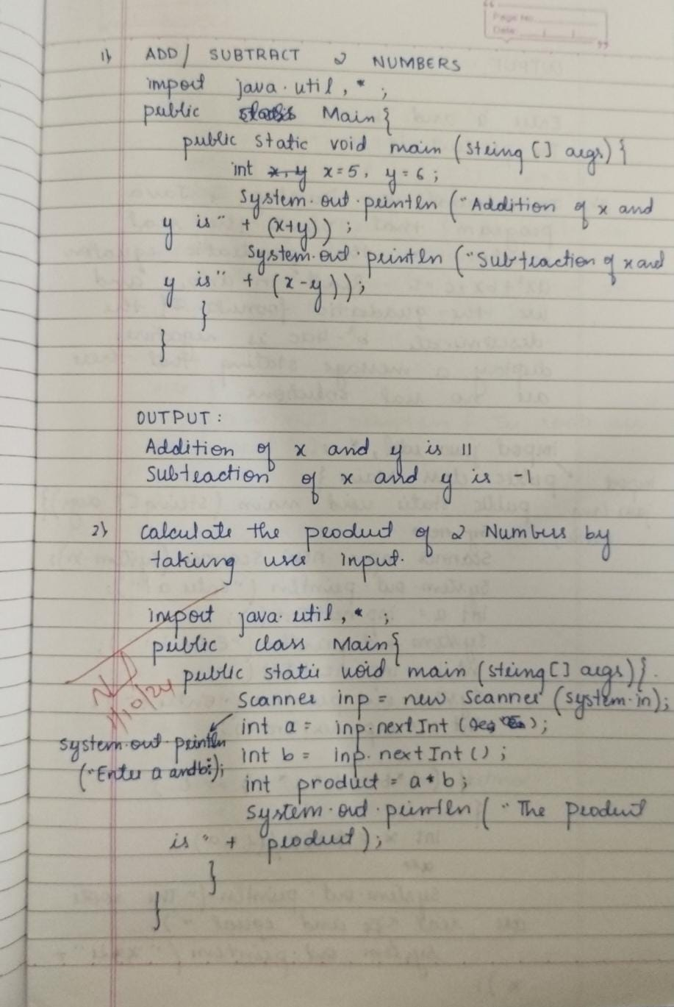

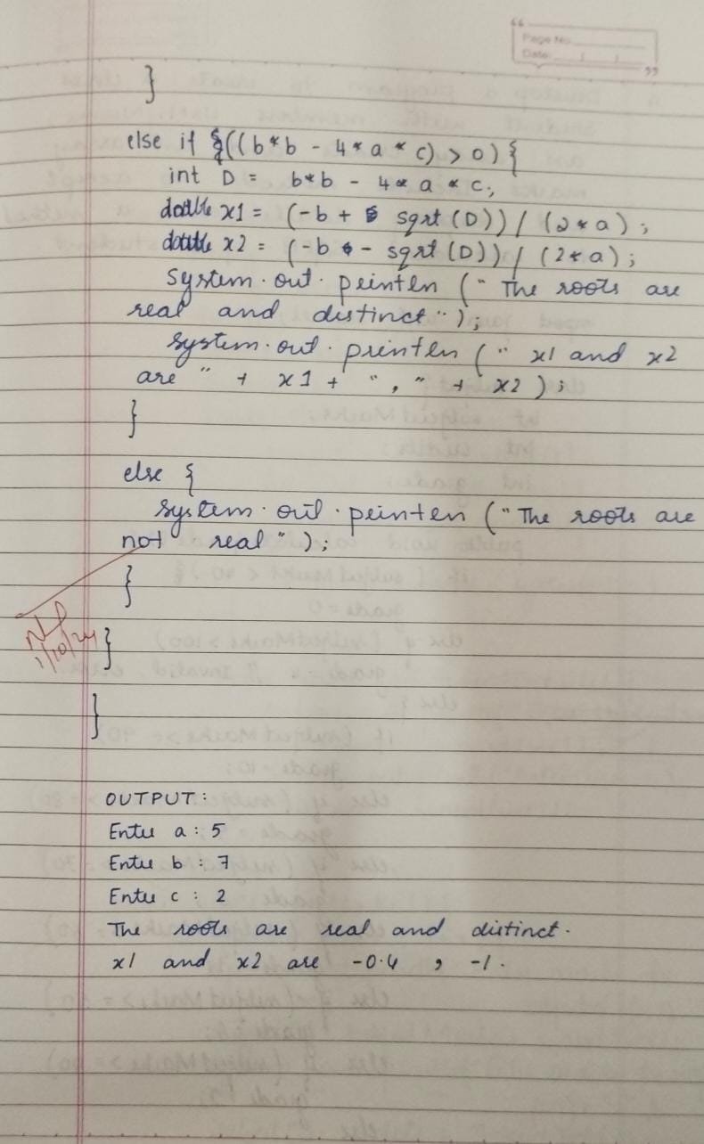

**Lab3**

**Program1:**

import java.util.Scanner;

class Subject {

int subjectMarks;

int credits;

int grade;

public void calculateGrade() {

if (subjectMarks < 40)

grade = 0;

else if (subjectMarks > 100)

grade = 4; // Invalid grade, assuming it’s an error

else {

if (subjectMarks >= 90)

grade = 10;

else if (subjectMarks >= 80)

grade = 9;

else if (subjectMarks >= 70)

grade = 8;

else if (subjectMarks >= 60)

grade = 7;

else if (subjectMarks >= 50)

grade = 6;

else if (subjectMarks >= 40)

grade = 5;

else

grade = -1;

}

}

}

class Student1 {

String name;

String usn;

double SGPA;

Subject subject[];

Scanner s;

Student1() {

subject = new Subject[8];

for (int i = 0; i < 8; i++) {

subject[i] = new Subject();

}

s = new Scanner(System.in);

}

public void getStudentDetails() {

System.out.print("Enter student name: ");

this.name = s.nextLine();

System.out.print("Enter student USN: ");

this.usn = s.nextLine();

}

public void getMarks() {

for (int i = 0; i < 8; i++) {

System.out.print("Enter marks for subject " + (i + 1) + ": ");

subject[i].subjectMarks = s.nextInt();

System.out.print("Enter credits for subject " + (i + 1) + ": ");

subject[i].credits = s.nextInt();

subject[i].calculateGrade();

}

s.nextLine();

}

public void computeSGPA() {

double totalPoints = 0;

int totalCredits = 0;

for (int i = 0; i < 8; i++) {

totalPoints += subject[i].grade * subject[i].credits;

totalCredits += subject[i].credits;

}

SGPA = (totalCredits == 0) ? 0 : totalPoints / totalCredits; }

public void displayResults() {

System.out.println("Student Name: " + name);

System.out.println("USN: " + usn);

System.out.printf("SGPA: %.2f%n", SGPA);

}

}

public class Student {

public static void main(String[] args) {

Student1 s1 = new Student1();

s1.getStudentDetails();

s1.getMarks();

s1.computeSGPA();

s1.displayResults();

}

}

**Output:**

Enter student name: Hitha Harish

Enter student USN: 115

Enter marks for subject 1: 90

Enter credits for subject 1: 4

Enter marks for subject 2: 89

Enter credits for subject 2: 4

Enter marks for subject 3: 98

Enter credits for subject 3: 4

Enter marks for subject 4: 86

Enter credits for subject 4: 3

Enter marks for subject 5: 87

Enter credits for subject 5: 3

Enter marks for subject 6: 90

Enter credits for subject 6: 2

Enter marks for subject 7: 97

Enter credits for subject 7: 1

Enter marks for subject 8: 94

Enter credits for subject 8: 1

Student Name: Hitha Harish

USN: 115

SGPA: 9.55

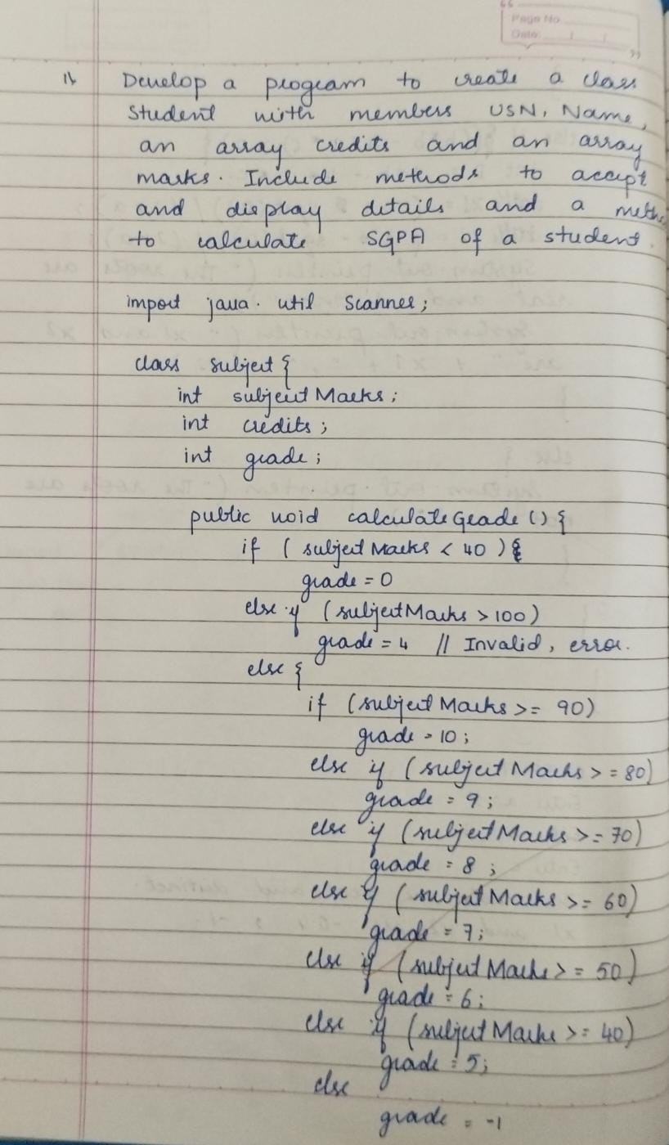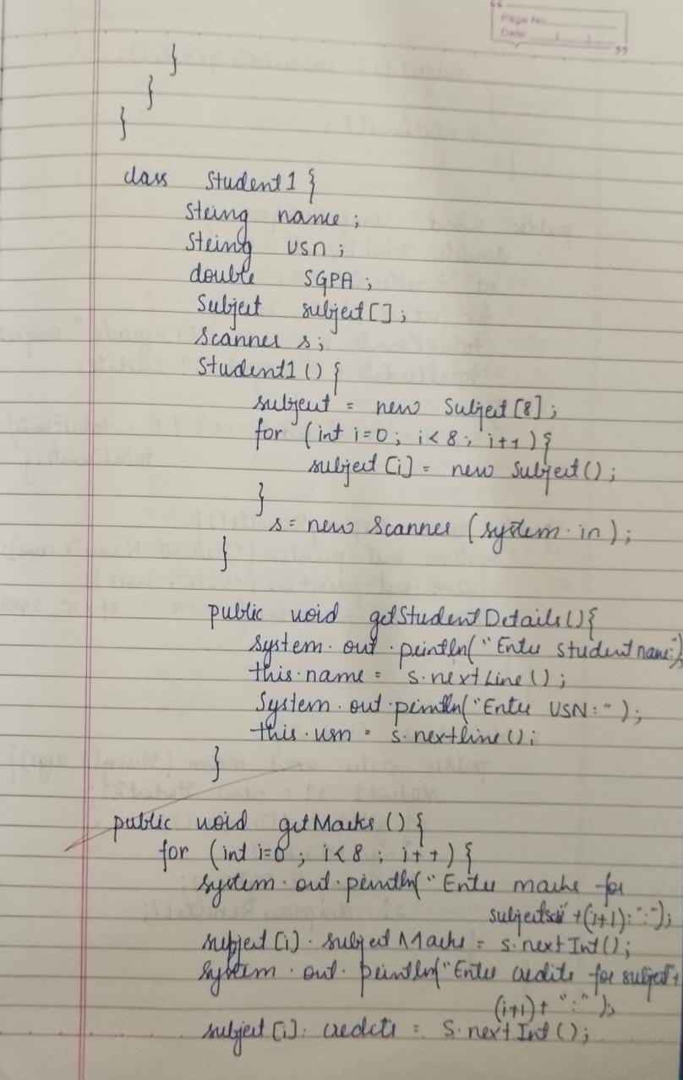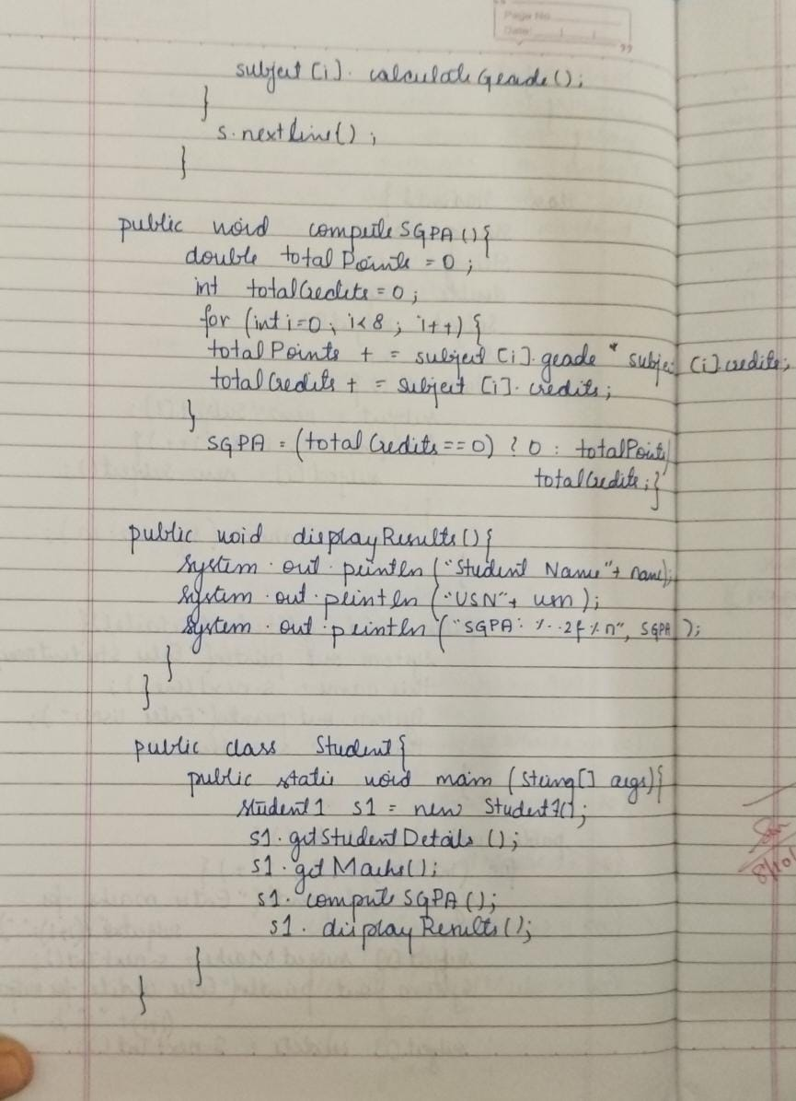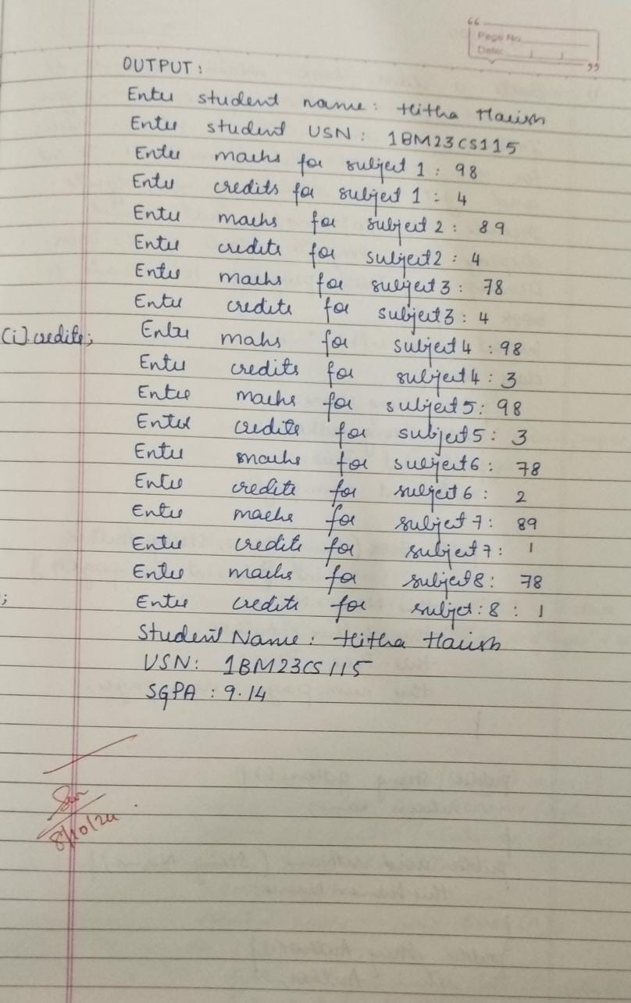

**Lab4:**

**Program1:**

import java.util.*;

class Book {

public String name;

public String author;

public double price;

public int num_pages;

public Book(String name, String author, double price, int num_pages) {

this.name = name;

this.author = author;

this.price = price;

this.num_pages = num_pages;

}

public String getName() {

return name;

}

public void setName(String name) {

this.name = name;

}

public String getAuthor() {

return author;

}

public void setAuthor(String author) {

this.author = author;

}

public double getPrice() {

return price;

}

public void setPrice(double price) {

this.price = price;

}

public int getNumPages() {

return num_pages;

}

public void setNumPages(int num_pages) {

this.num_pages = num_pages;

}

@Override

public String toString() {

return "Book Name: " + name + ", Author: " + author +

", Price: $" + price + ", Pages: " + num_pages;

}

}

public class Main {

public static void main(String[] args) {

Scanner scanner = new Scanner(System.in);

System.out.print("Enter the number of books: ");

int n = scanner.nextInt();

scanner.nextLine(); // Consume the newline

Book[] books = new Book[n];

for (int i = 0; i < n; i++) {

System.out.println("Enter details for Book " + (i + 1) + ":");

System.out.print("Name: ");

String name = scanner.nextLine();

System.out.print("Author: ");

String author = scanner.nextLine();

System.out.print("Price: ");

double price = scanner.nextDouble();

System.out.print("Number of Pages: ");

int num_pages = scanner.nextInt();

scanner.nextLine(); // Consume the newline

books[i] = new Book(name, author, price, num_pages);

}

System.out.println("\nDetails of all books:");

for (Book book : books) {

System.out.println(book);

}

scanner.close();

}

}

**Output:**

Enter the number of books: 2

Enter details for Book 1:

Name: abc

Author: xyz

Price: 50

Number of Pages: 45

Enter details for Book 2:

Name: pqr

Author: lmn

Price: 78

Number of Pages: 96

Details of all books:

Book Name: abc, Author: xyz, Price: $50.0, Pages: 45

Book Name: pqr, Author: lmn, Price: $78.0, Pages: 96

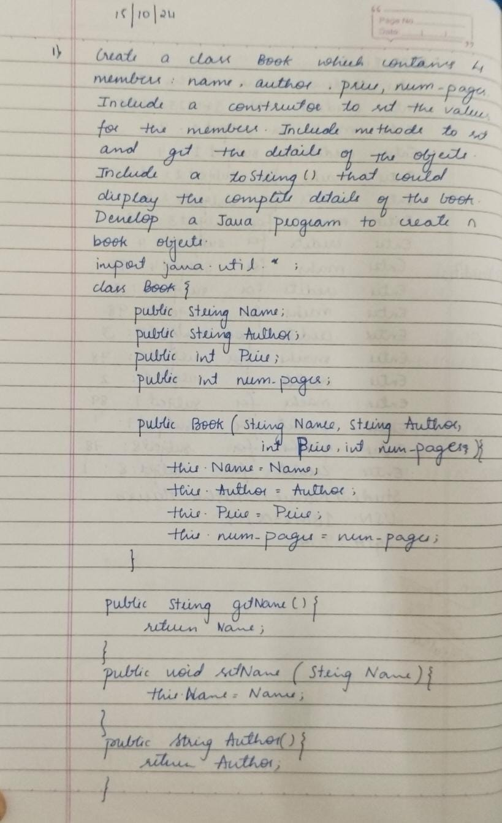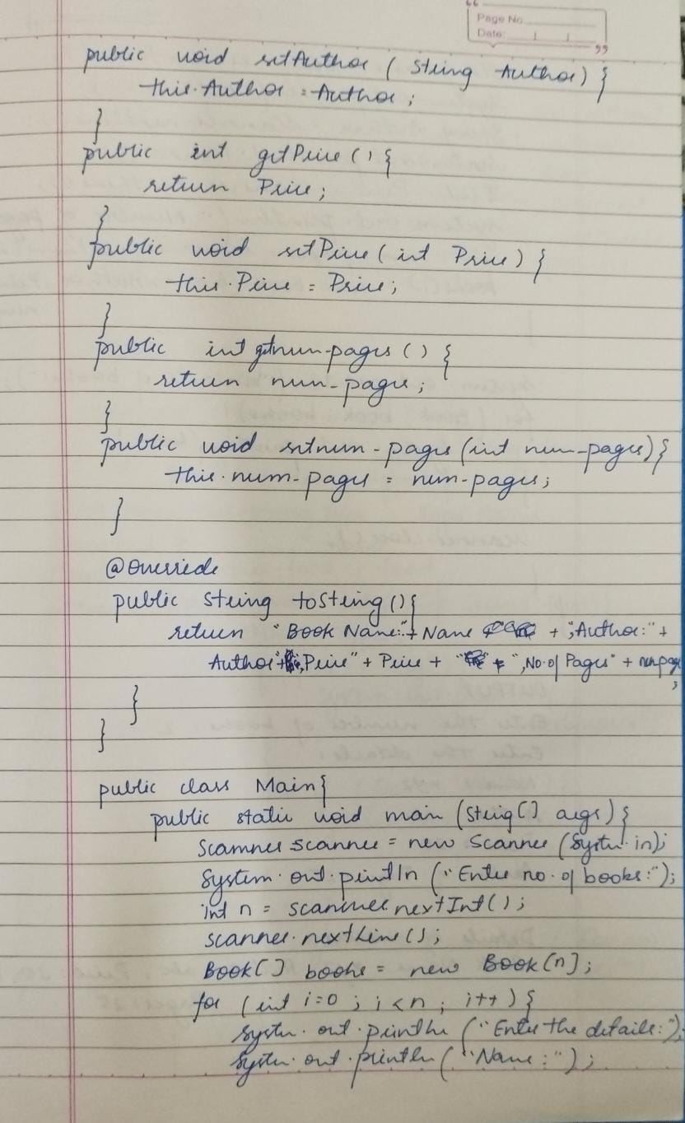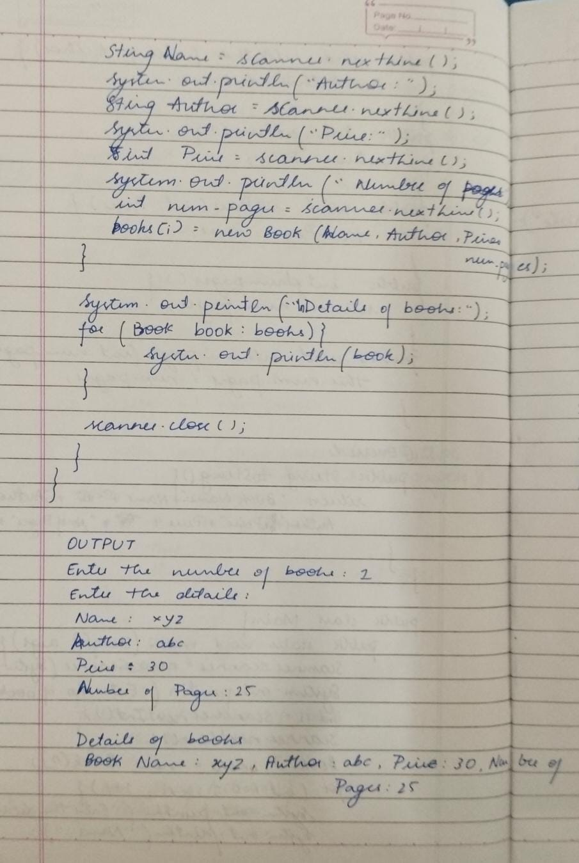

**Lab5:**

**Program1:**

import java.util.*;

abstract class Animal{

String Name;

String Food;

String Sleep;

abstract void eat();

abstract void sleep();

}

class Lion extends Animal{

void eat(){

System.out.println("Carnivorous");

}

void sleep(){

System.out.println("12 hours");

}

}

class Tiger extends Animal{

void eat(){

System.out.println("Carnivorous");

}

void sleep(){

System.out.println("10 hours");

}

}

class Deer extends Animal{

void eat(){

System.out.println("Herbivorous");

}

void sleep(){

System.out.println("8 hours");

}

}

public class Main{

public static void main(String[] args){

Lion L=new Lion();

L.eat();

L.sleep();

Tiger T=new Tiger();

T.eat();

T.sleep();

Deer D=new Deer();

D.eat();

D.sleep();

}

}

**Output:**

Carnivorous

12 hours

Carnivorous

10 hours

Herbivorous

8 hours

**Program2:**

import java.util.*;

abstract class Shape{

abstract void printArea();

}

class Rectangle extends Shape{

double l;

double b;

Rectangle(double l,double b){

this.l=l;

this.b=b;

}

void printArea(){

System.out.println(l*b);

}

}

class Triangle extends Shape{

double h;

double b;

Triangle(double h,double b){

this.h=h;

this.b=b;

}

void printArea(){

System.out.println(0.5*h*b);

}

}

class Circle extends Shape{

double r;

Circle(double r){

this.r=r;

}

void printArea(){

System.out.println(3.14*r*r);

}

}

public class Main1{

public static void main(String[] args){

Rectangle R=new Rectangle(5,6);

R.printArea();

Triangle T=new Triangle(2,5);

T.printArea();

Circle C=new Circle(1);

C.printArea();

}

}

**Output:**

30.0

5.0

3.14

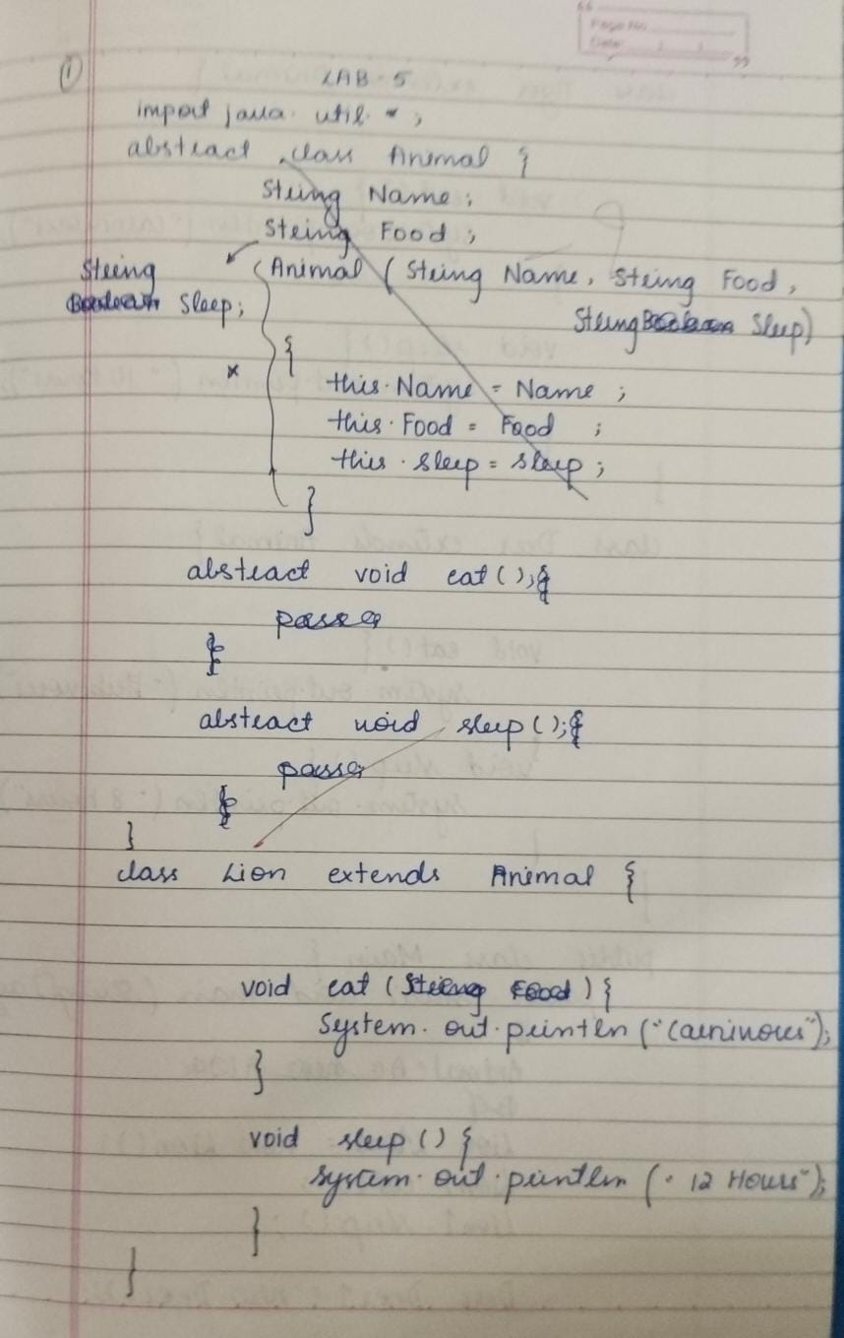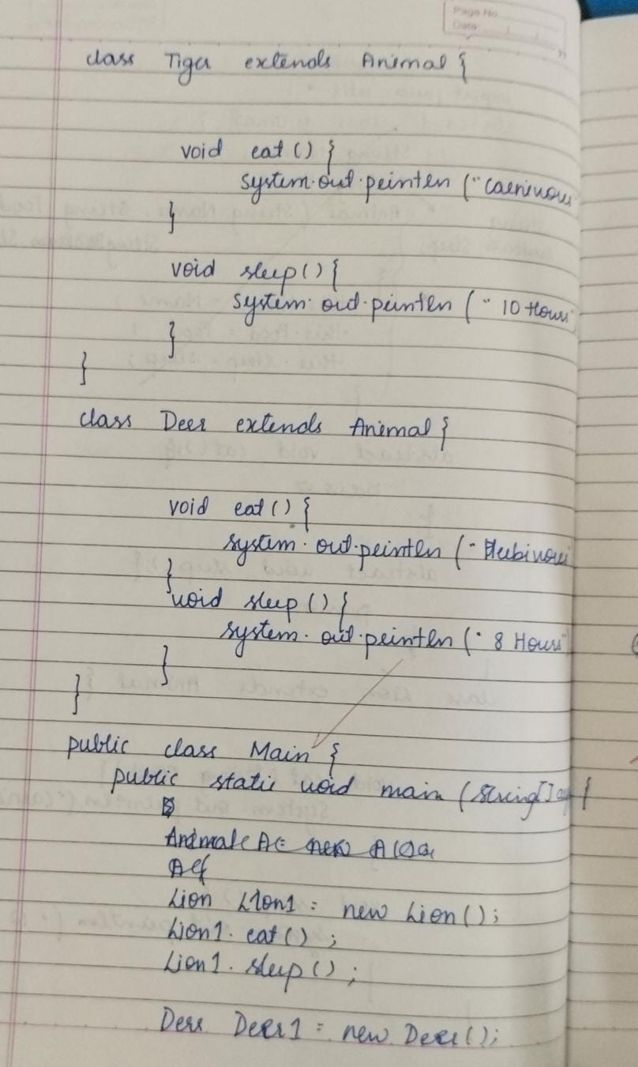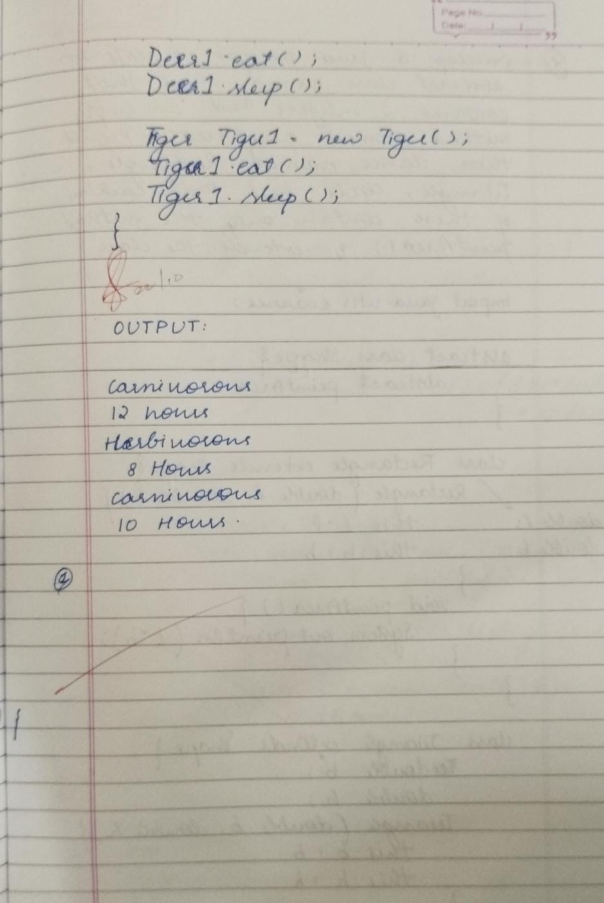

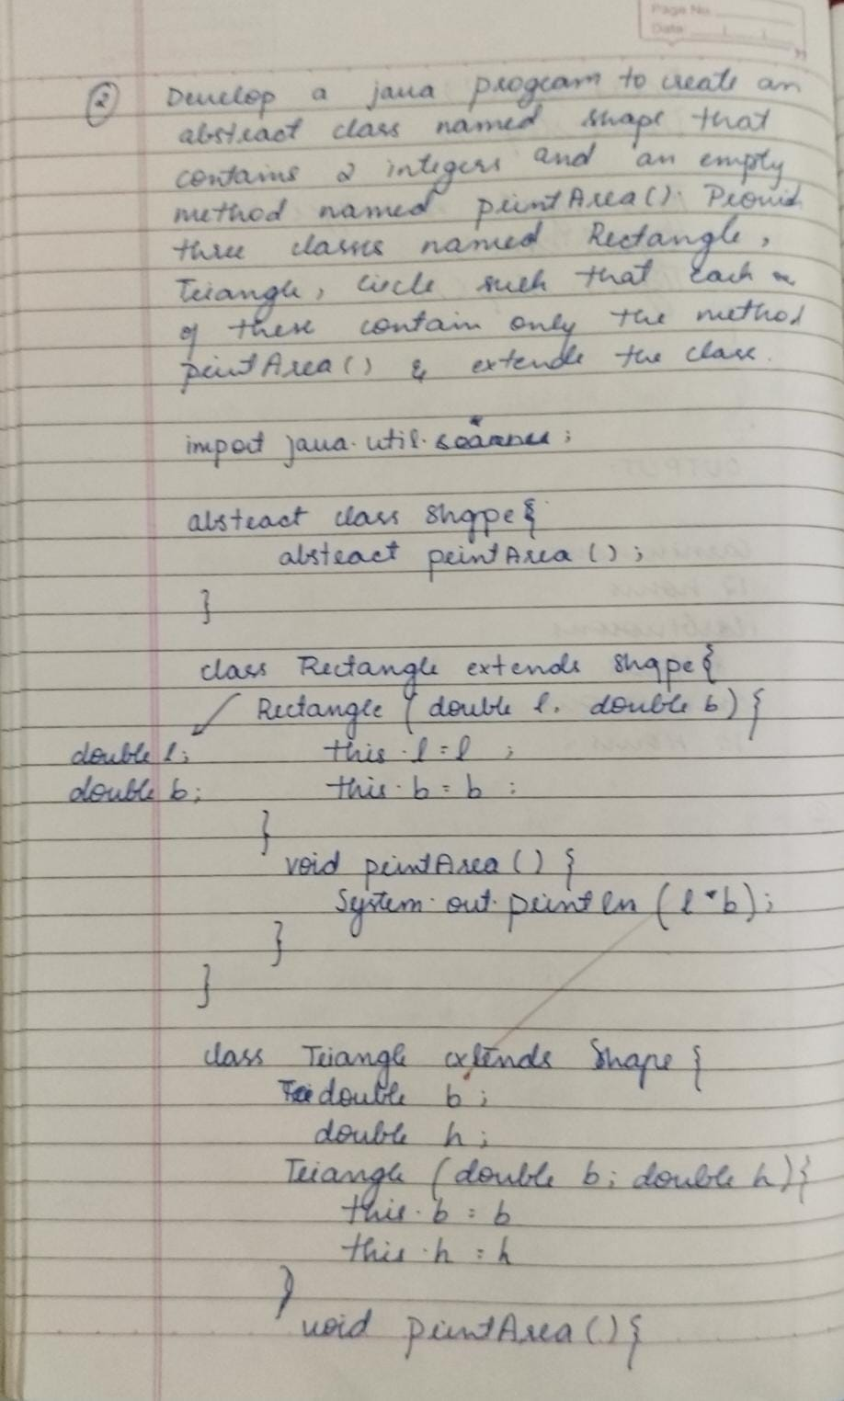

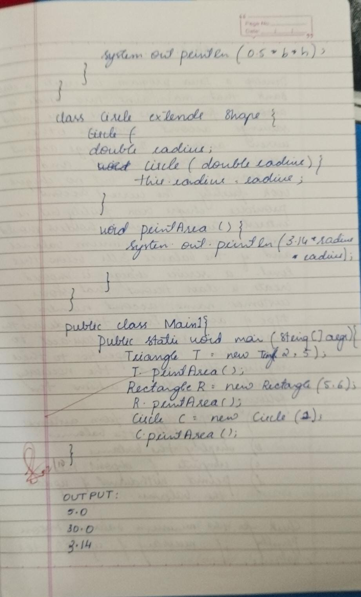

**Lab6:**

**Program1:**

class Account {

String customerName;

int accountNumber;

String accountType;

double balance;

public Account(String customerName, int accountNumber, String accountType, double initialBalance) {

this.customerName = customerName;

this.accountNumber = accountNumber;

this.accountType = accountType;

this.balance = initialBalance; // Corrected to use initialBalance

}

public void deposit(double amount) {

if (amount > 0) {

this.balance += amount; // Simplified

System.out.println("Deposited: $" + amount);

} else {

System.out.println("Invalid deposit amount.");

}

}

public void displayBalance() {

System.out.println("Account Balance: $" + balance);

}

public void withdraw(double amount) {

if (amount <= balance) {

balance -= amount;

System.out.println("Withdrew: $" + amount);

} else {

System.out.println("Insufficient balance.");

}

}

}

class SavAcct extends Account {

double interestRate;

public SavAcct(String customerName, int accountNumber, double balance, double interestRate) {

super(customerName, accountNumber, "Savings", balance);

this.interestRate = interestRate;

}

public void computeInterest() {

double interest = (balance * interestRate) / 100;

balance += interest;

System.out.println("Interest added: $" + interest);

}

}

class CurAcct extends Account {

double minimumBalance;

double serviceCharge;

public CurAcct(String customerName, int accountNumber, double balance, double minimumBalance, double serviceCharge) {

super(customerName, accountNumber, "Current", balance);

this.minimumBalance = minimumBalance;

this.serviceCharge = serviceCharge;

}

@Override

public void withdraw(double amount) {

if (amount <= balance) {

balance -= amount;

System.out.println("Withdrew: $" + amount);

if (balance < minimumBalance) {

balance -= serviceCharge;

System.out.println("Service charge imposed: $" + serviceCharge);

}

} else {

System.out.println("Insufficient balance.");

}

}

}

public class Bank {

public static void main(String[] args) {

SavAcct S = new SavAcct("Hitha Harish", 2152, 10000, 5);

S.computeInterest();

S.deposit(1000);

S.displayBalance();

S.withdraw(500);

S.displayBalance();

System.out.println();

CurAcct C = new CurAcct("Jane", 102, 3000, 1000, 50);

C.deposit(2000);

C.displayBalance();

C.withdraw(2000);

C.withdraw(2500);

C.displayBalance();

}

}

**Output:**

Interest added: $500.0

Deposited: $1000.0

Account Balance: $11500.0

Withdrew: $500.0

Account Balance: $11000.0

Deposited: $2000.0

Account Balance: $5000.0

Withdrew: $2000.0

Withdrew: $2500.0

Service charge imposed: $50.0

Account Balance: $450.0

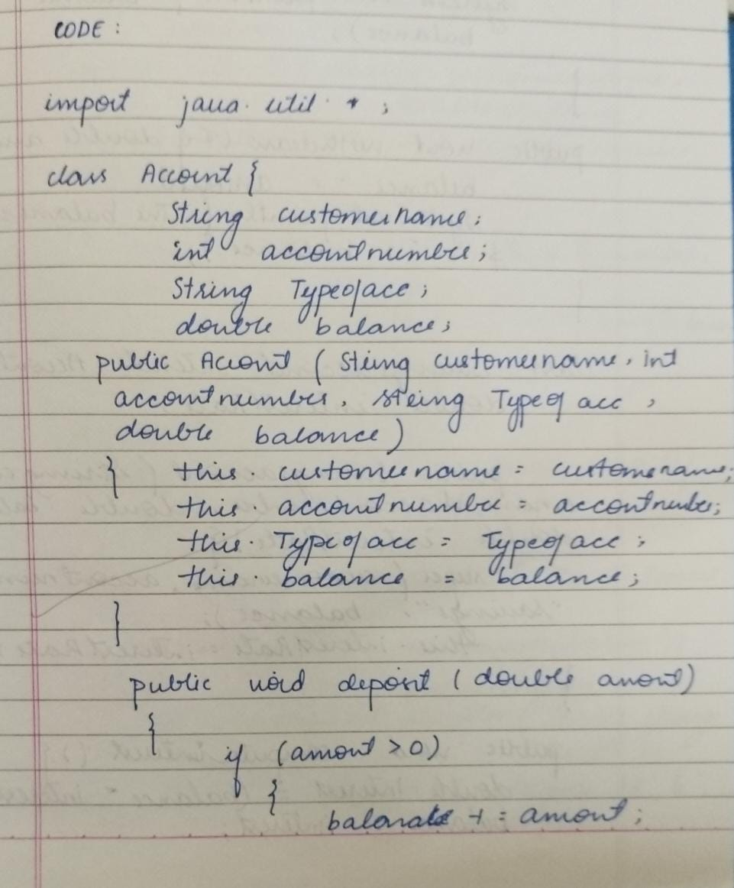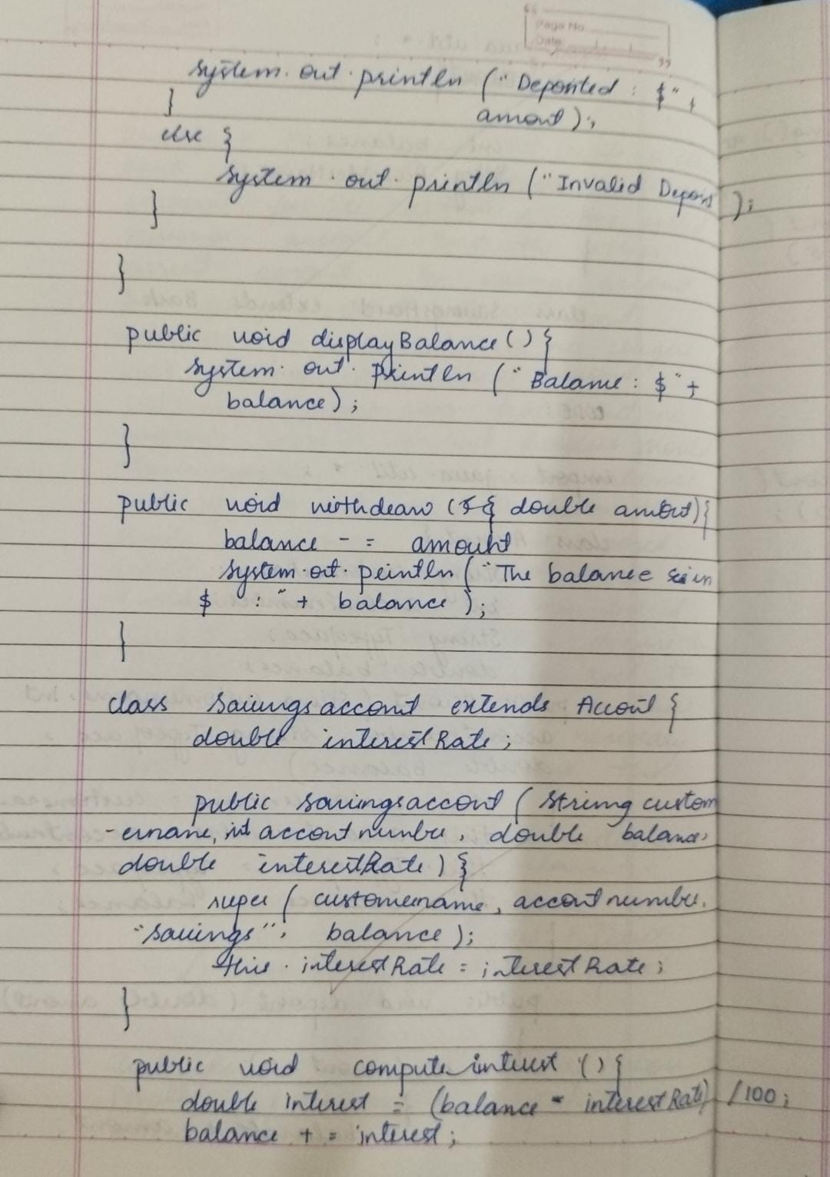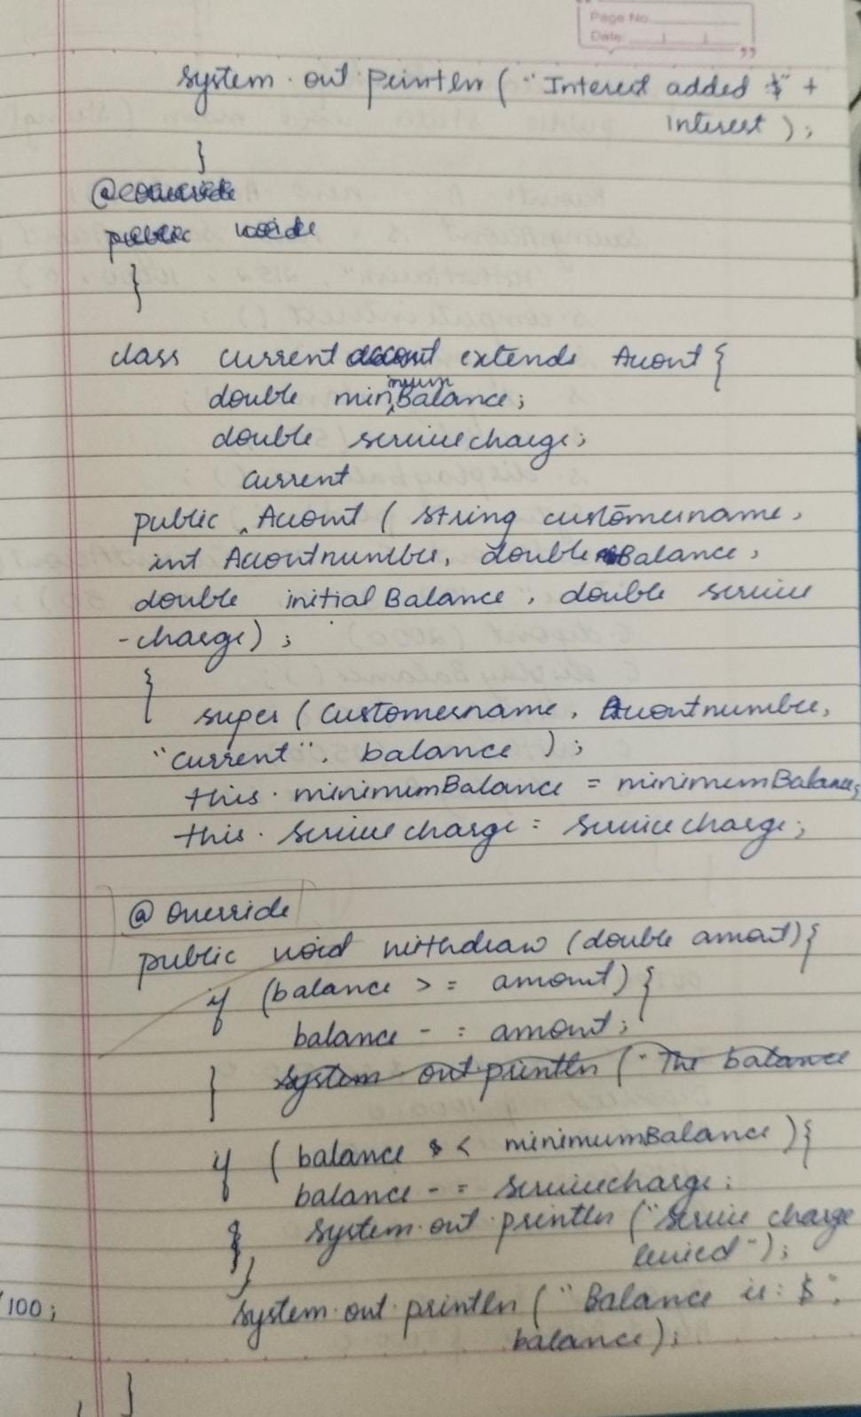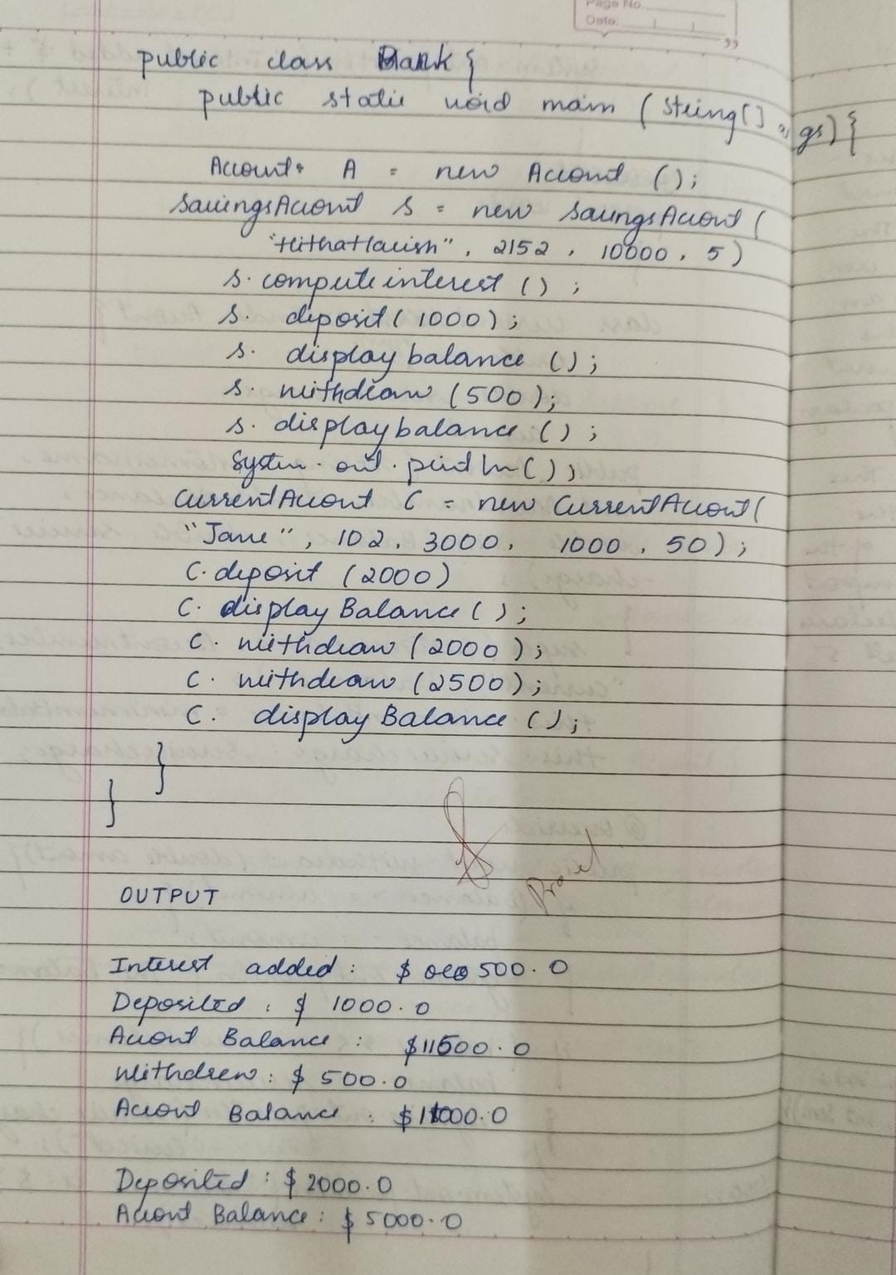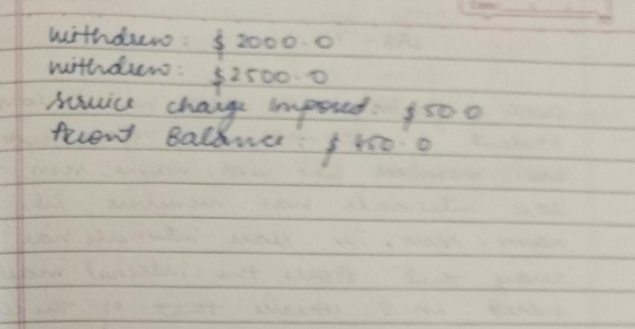

**Lab7:**

**Program1:**

package CIE;

import java.util.Scanner;

public class Student {

protected String usn;

protected String name;

protected int sem;

// Method to input student details

public void inputStudentDetails() {

Scanner s = new Scanner(System.in);

System.out.println("Enter USN: ");

usn = s.nextLine();

System.out.println("Enter Name: ");

name = s.nextLine();

System.out.println("Enter Semester: ");

sem = s.nextInt();

}

// Method to display student details

public void displayStudentDetails() {

System.out.println("USN: " + usn);

System.out.println("Name: " + name);

System.out.println("Semester: " + sem);

}

}

package CIE;

import java.util.Scanner;

public class Internals extends Student {

protected int[] marks = new int[5]; // Array to store internal marks for 5 courses

// Method to input internal marks for five courses

public void inputCIEmarks() {

Scanner s = new Scanner(System.in);

System.out.println("Enter Internal Marks for 5 Courses: ");

for (int i = 0; i < 5; i++) {

System.out.println("Enter marks for course " + (i + 1) + ": ");

marks[i] = s.nextInt();

}

}

// Method to display internal marks

public void displayCIEmarks() {

System.out.println("Internal Marks: ");

for (int i = 0; i < 5; i++) {

System.out.println("Course " + (i + 1) + ": " + marks[i]);

}

}

}

package SEE;

import CIE.Internals;

import java.util.Scanner;

public class External extends Internals {

protected int[] externalMarks = new int[5]; // Array to store external marks for 5 courses

protected int[] finalMarks = new int[5]; // Array to store final marks (internal + external)

// Method to input external marks for five courses

public void inputSEEmarks() {

Scanner s = new Scanner(System.in);

System.out.println("Enter External Marks for 5 Courses: ");

for (int i = 0; i < 5; i++) {

System.out.println("Enter marks for course " + (i + 1) + ": ");

externalMarks[i] = s.nextInt();

}

}

// Method to calculate final marks (internal + external)

public void calculateFinalMarks() {

for (int i = 0; i < 5; i++) {

finalMarks[i] = marks[i] + externalMarks[i]; // Adding internal and external marks

}

}

// Method to display final marks along with student details

public void displayFinalMarks() {

displayStudentDetails(); // Display student details

displayCIEmarks(); // Display internal marks

System.out.println("External Marks: ");

for (int i = 0; i < 5; i++) {

System.out.println("Course " + (i + 1) + ": " + externalMarks[i]);

}

System.out.println("Final Marks: ");

for (int i = 0; i < 5; i++) {

System.out.println("Course " + (i + 1) + ": " + finalMarks[i]);

}

}

}

import SEE.External;

import java.util.Scanner;

public class Main {

public static void main(String[] args) {

Scanner sc = new Scanner(System.in);

System.out.print("Enter the number of students: ");

int n = sc.nextInt();

sc.nextLine(); // Consume the newline character

// Array to store External objects

External[] students = new External[n];

// Input details for each student

for (int i = 0; i < n; i++) {

students[i] = new External();

System.out.println("Enter details for student " + (i + 1));

students[i].inputStudentDetails();

students[i].inputCIEmarks();

students[i].inputSEEmarks();

}

// Calculate and display final marks for each student

for (int i = 0; i < n; i++) {

students[i].calculateFinalMarks();

students[i].displayFinalMarks();

}

sc.close();

}

}

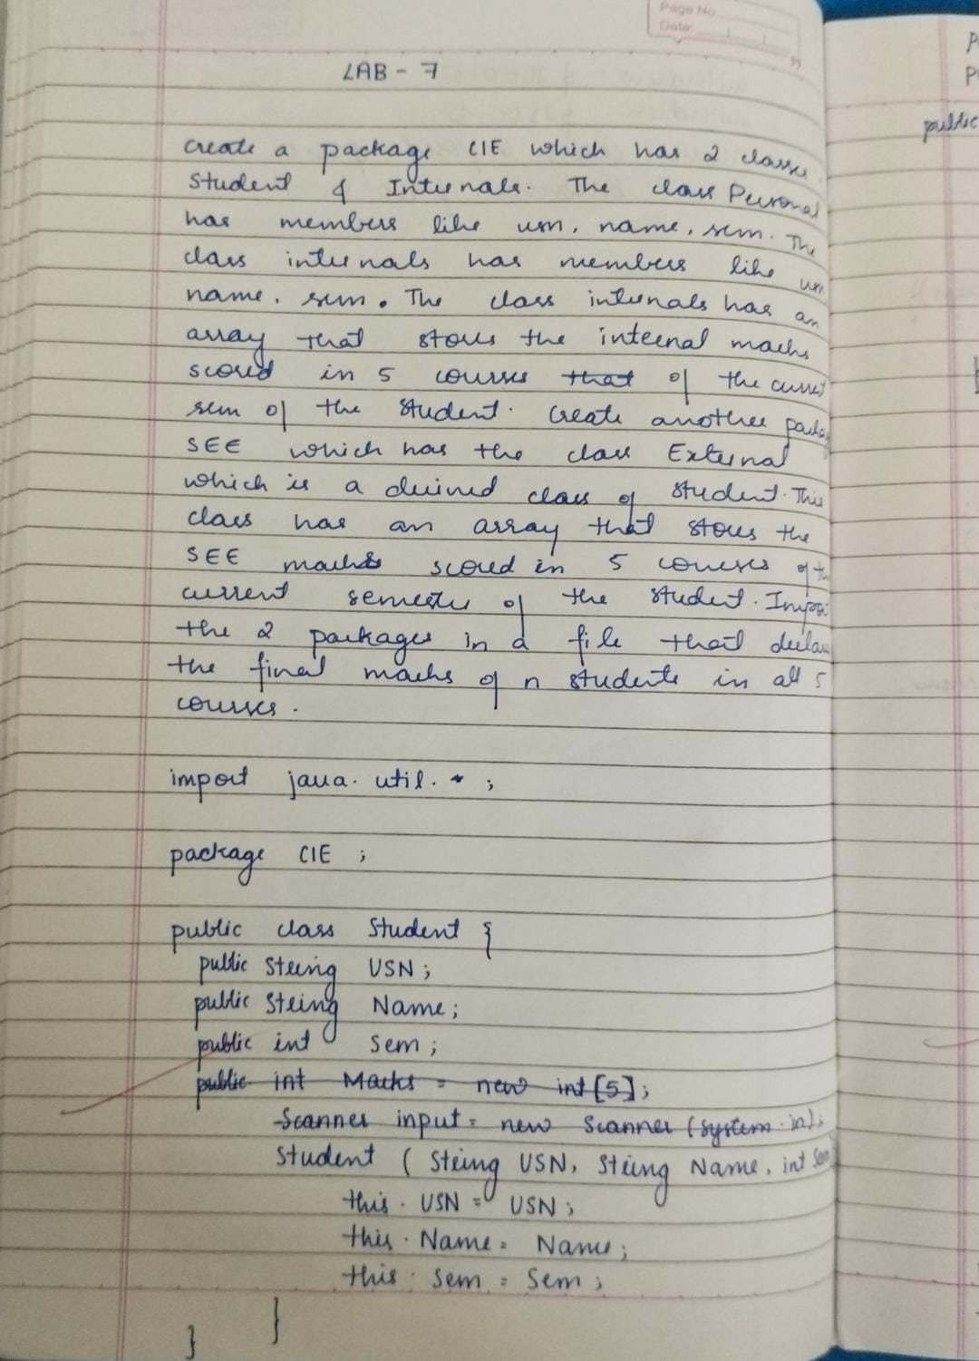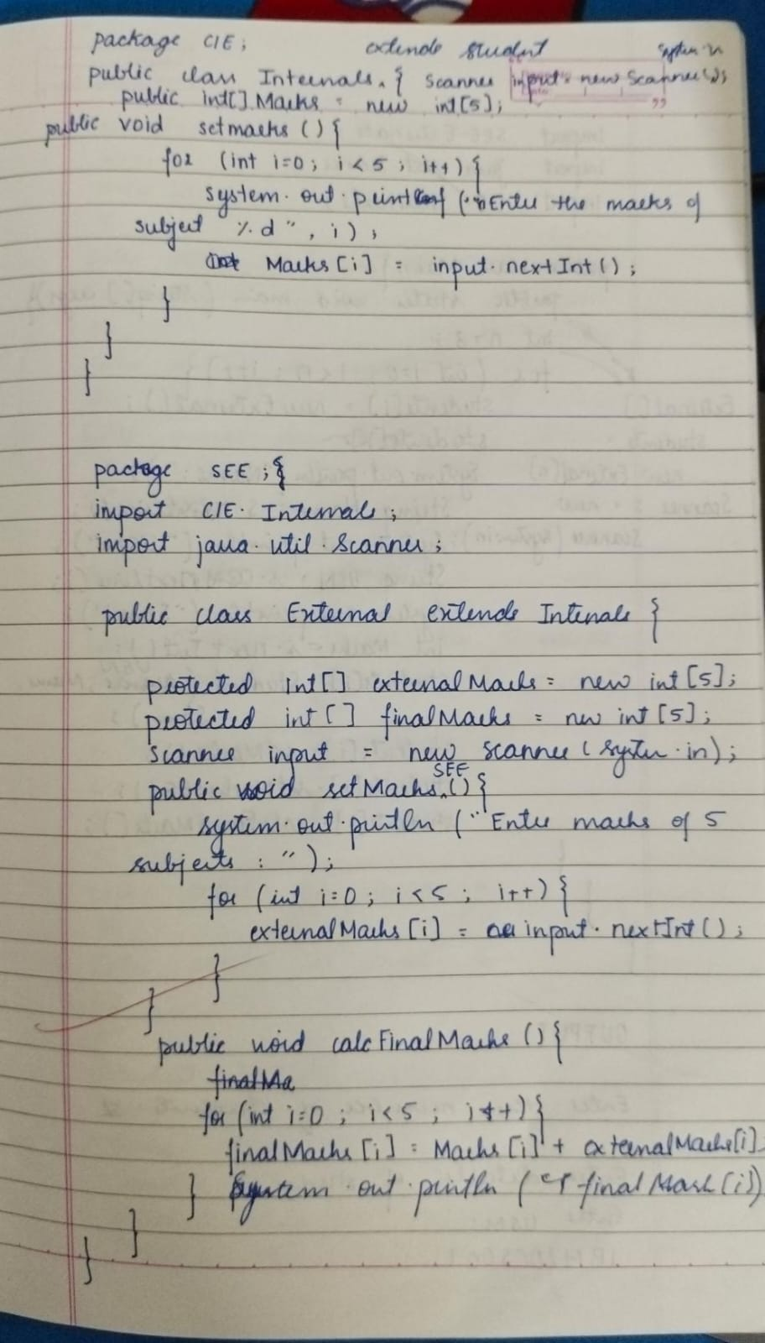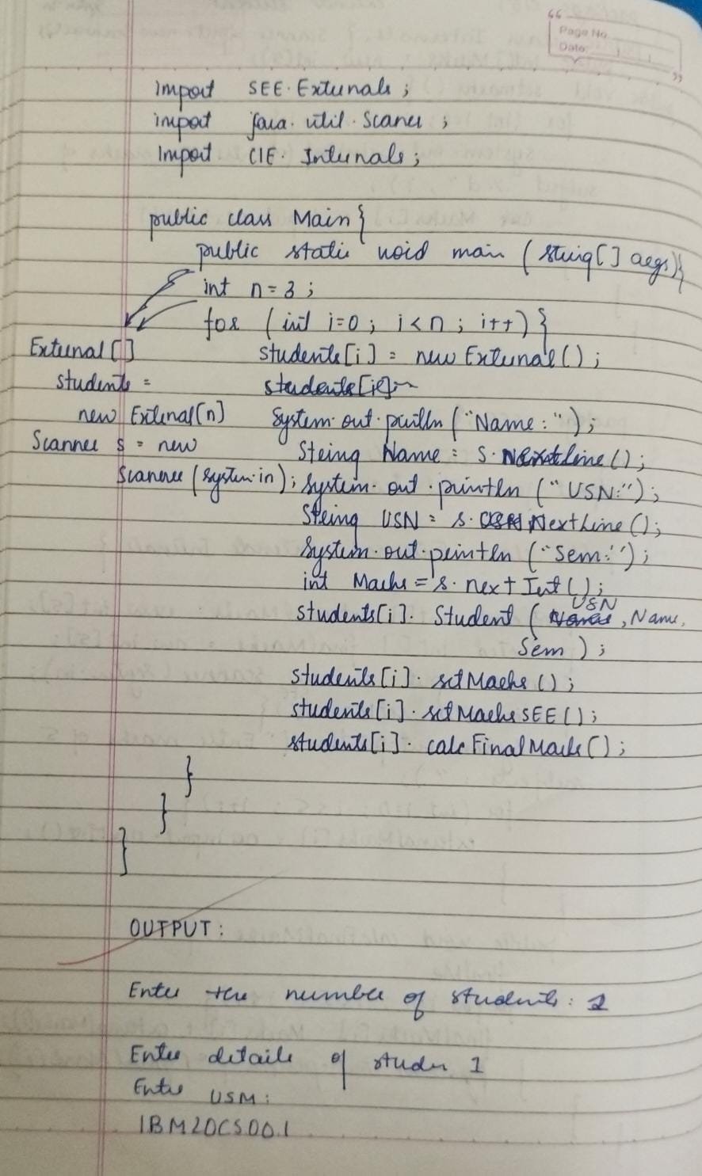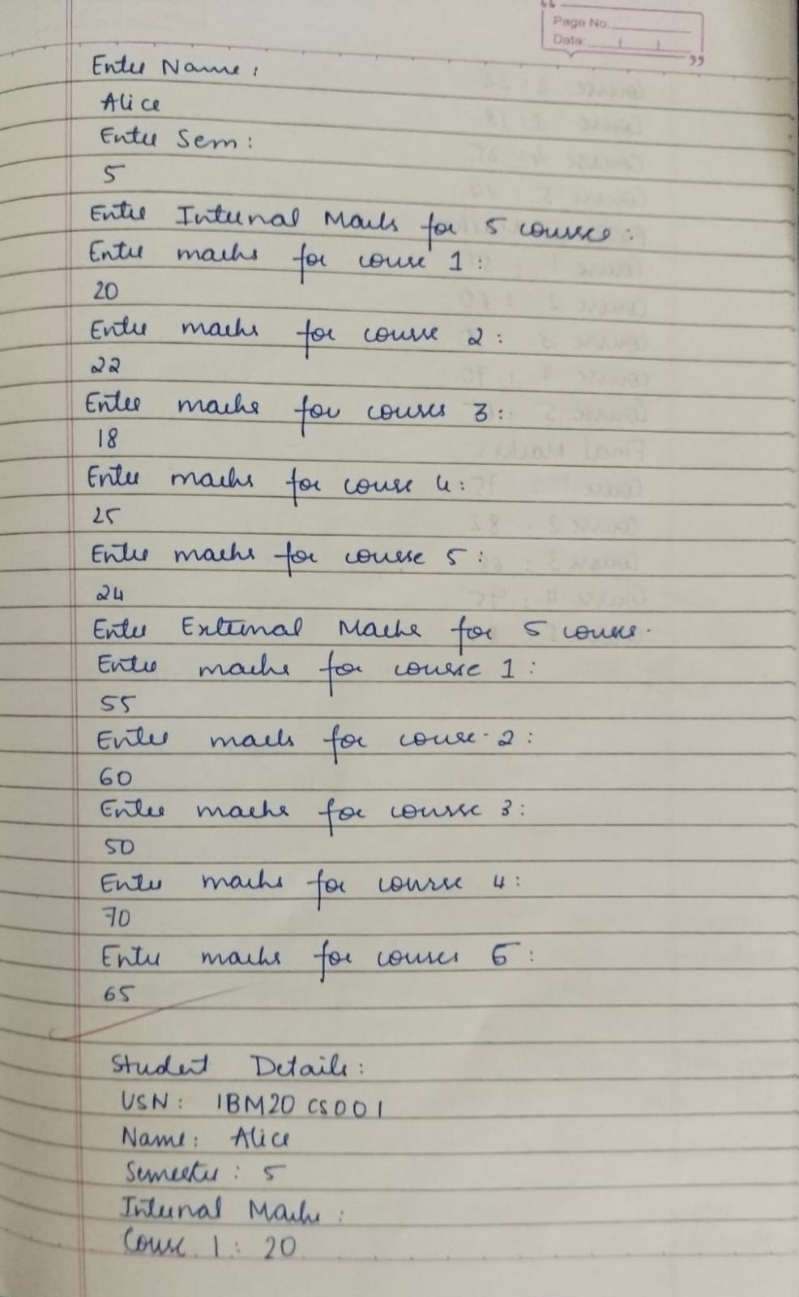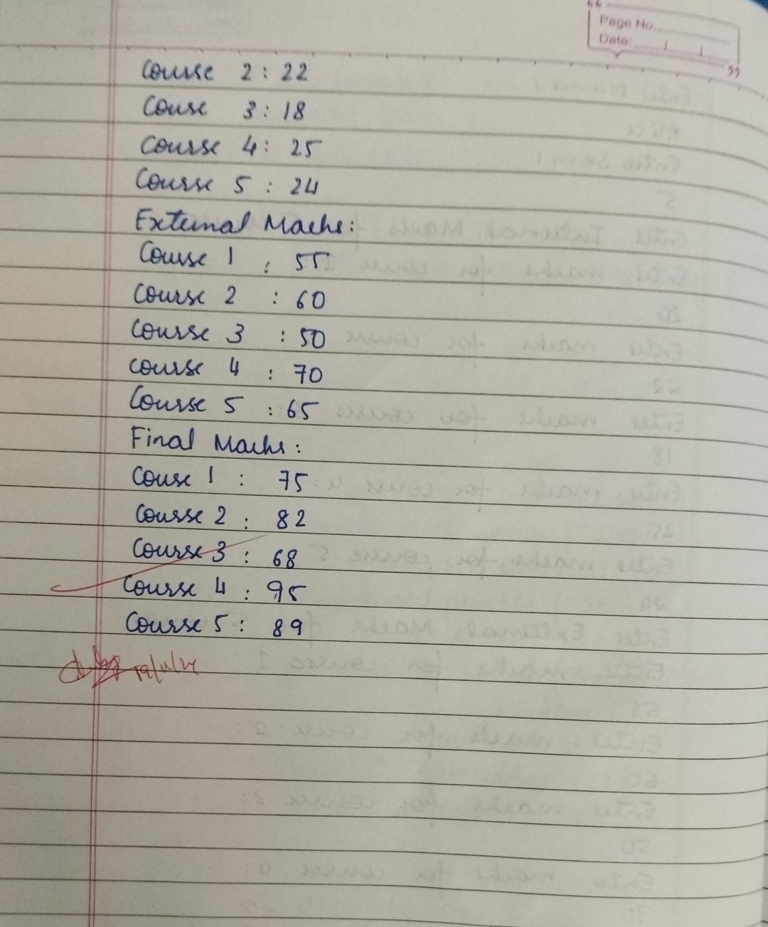

**Lab8:**

**Program1:**

import java.util.*;

interface Polygon{

void getPerimeter();

public abstract void getArea();

}

class Shape implements Polygon{

int n;

Shape(int n){

this.n=n;

}

public void getPerimeter(){

int P=0;

Scanner input = new Scanner(System.in);

for (int i=0; i<n; i++){

System.out.println("Enter the length of the side:");

int l=input.nextInt();

P+=l;

}

System.out.println("The Perimeter is:"+P);

}

public void getArea(){

System.out.println("Area is implemented");

}

}

public class Main2{

public static void main(String args[]){

Scanner input = new Scanner(System.in);

System.out.println("Enter the no. of sides:");

int n=input.nextInt();

Polygon S= new Shape(n);

S.getPerimeter();

S.getArea();

}

}

**Output:**

Enter the no. of sides:

3

Enter the length of the side:

2

Enter the length of the side:

2

Enter the length of the side:

3

The Perimeter is:7

Area is implemented

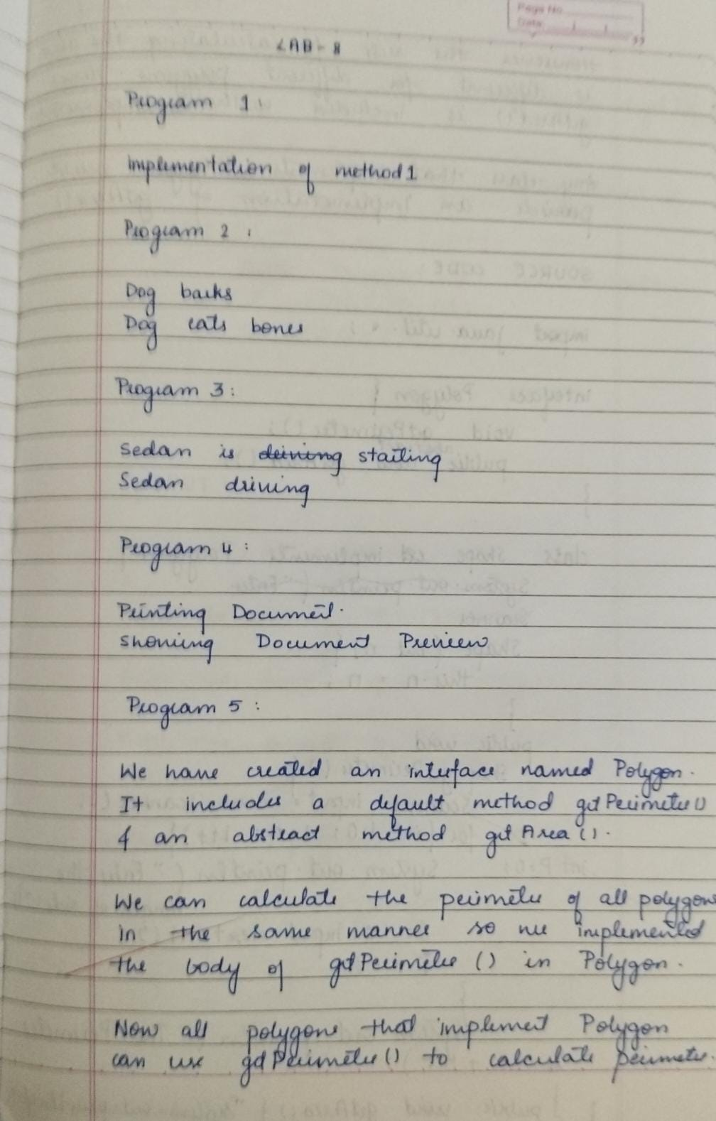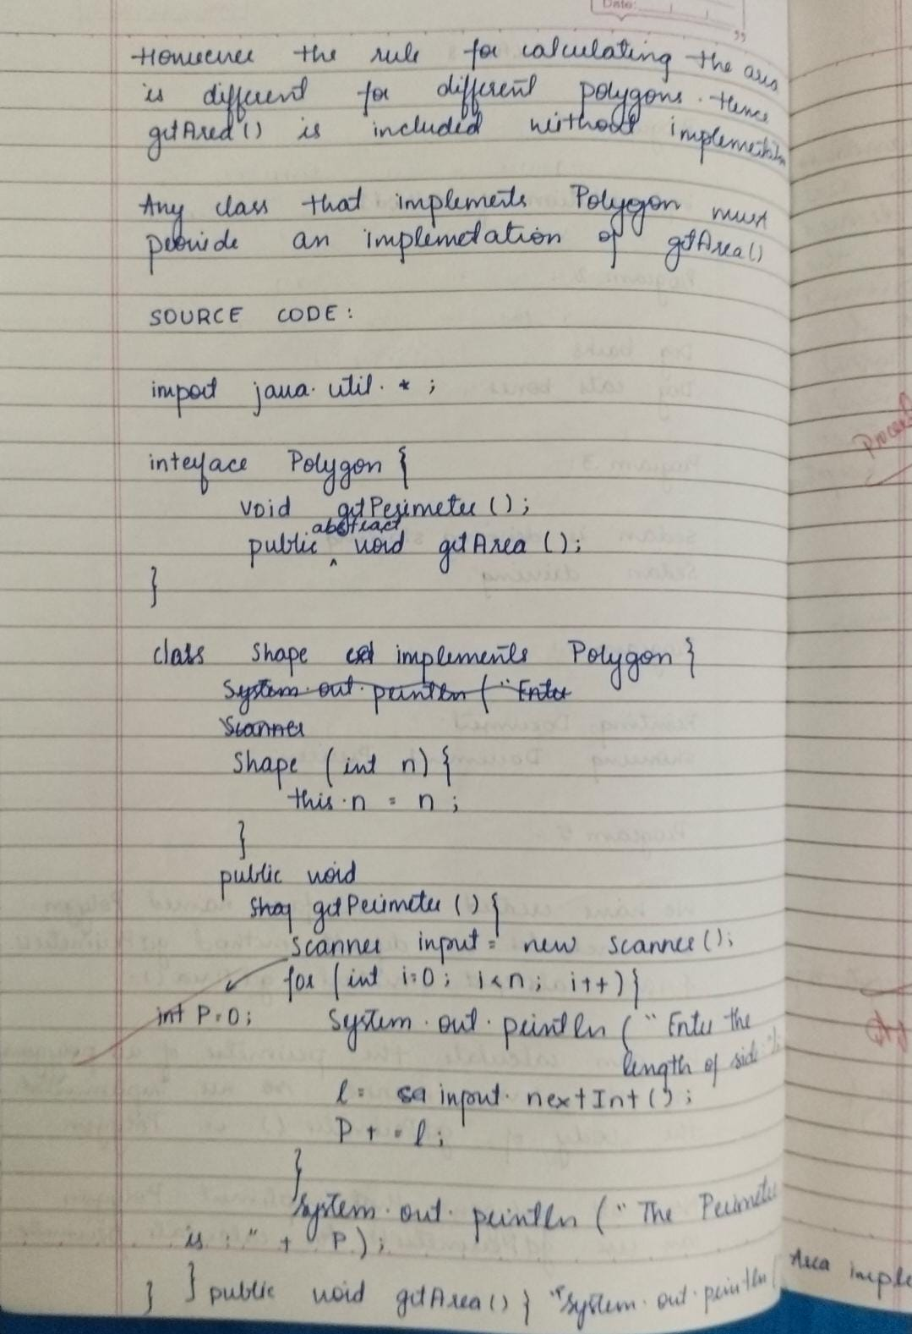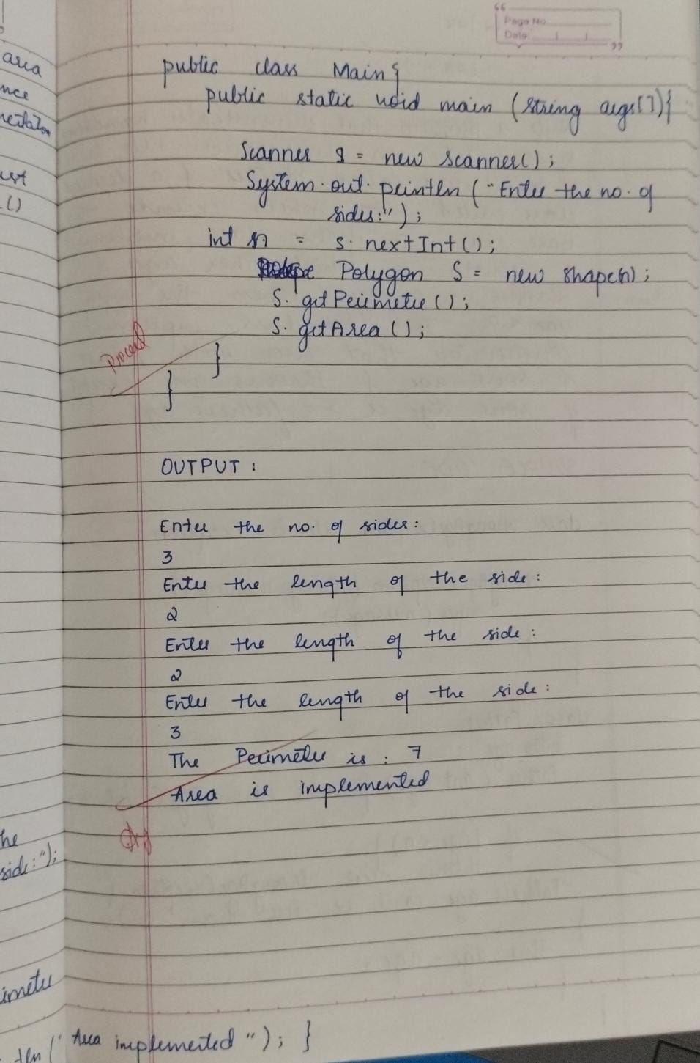

**Lab9:**

**Program1:**

class Father {

int age;

Father(int age) throws WrongAgeException {

if (age <= 0) {

throw new WrongAgeException("Father's age can't be less than 0");

}

this.age = age;

}

}

class Son extends Father {

int age;

Son(int fatherAge, int age) throws WrongAgeException {

super(fatherAge);

if (age > fatherAge) {

throw new WrongAgeException("Son can't be older than father");

}

this.age = age;

}

}

class WrongAgeException extends Exception {

WrongAgeException(String message) {

super(message);

}

}

class Main {

public static void main(String[] args) {

try {

Father f1 = new Father(50);

Son s1 = new Son(f1.age, 10);

Father f2 = new Father(0);

Son s2 = new Son(f2.age, 10);

} catch (WrongAgeException e) {

System.out.println(e.getMessage());

}

}

}

**Output:**

Father's age can't be less than 0

Son can't be older than father

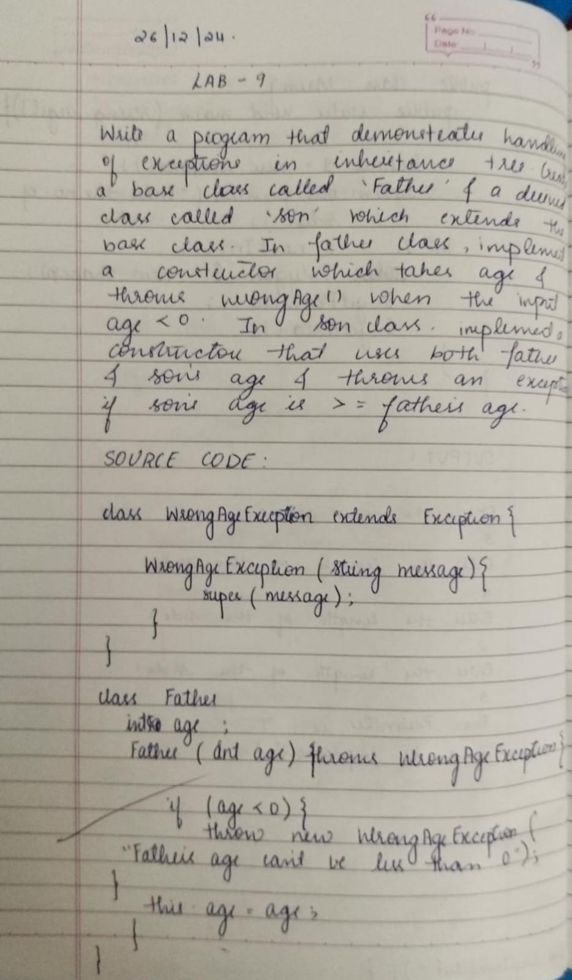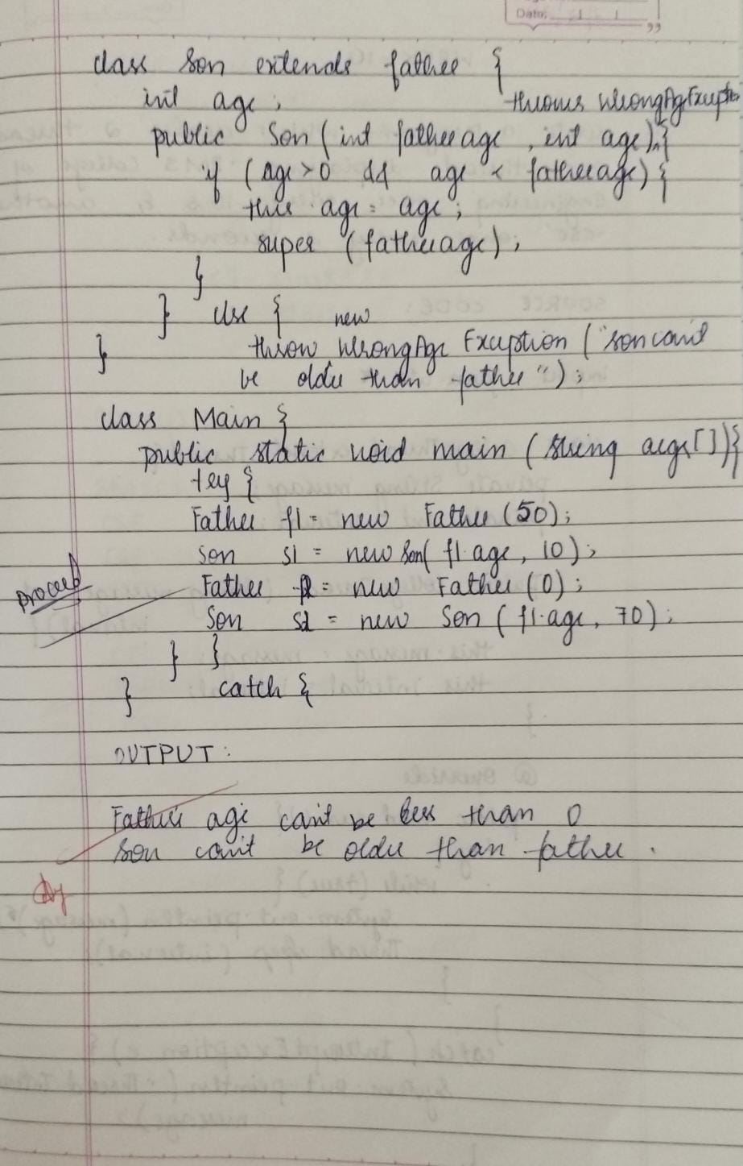

**Lab10:**

**Program1:**

class CollegeThread extends Thread{

private String message;

private int interval;

public CollegeThread(String message,int interval){

this.message=message;

this.interval=interval;

}

@ Override

public void run(){

try{

while(true){

System.out.println(message);

Thread.sleep(interval);

}

}

catch(InterruptedException e){

System.out.println("Thread Interrupted:" + message);

}

}

}

class Main{

public static void main(String args[]){

CollegeThread c1=new CollegeThread("BMSCE",10000);

CollegeThread c2=new CollegeThread("CSE",2000);

c1.start();

c2.start();

}

}

**Output:**

BMSCE

CSE

CSE

CSE

CSE

CSE

BMSCE

CSE

CSE

CSE

CSE

CSE

BMSCE

CSE

CSE

CSE

CSE

CSE

BMSCE

CSE

CSE

CSE

CSE

CSE

BMSCE

CSE

CSE

CSE

**Program2:**

import java.util.Scanner;

class Main{

public static void main(String args[]){

Scanner s = new Scanner(System.in);

try{

System.out.println("Enter num1:");

int num1=s.nextInt();

System.out.println("Enter num2:");

int num2=s.nextInt();

if (num2==0){

throw new ArithmeticException("cannot divide by zero");

}

System.out.println("Result:"+(num1/num2));

}

catch(ArithmeticException e){

System.out.println("Error:" + e.getMessage());

}

catch(Exception e){

System.out.println("Error: Enter A VALID INTEGER");

}

finally{

s.close();

}

}

}

**Output:**

Enter num1:

5

Enter num2:

6

Result:0

